Endometabolite composition differs among
temperature-acclimated cultures of Emiliania huxleyi

Non-Thesis Master’s Project
Jordan Allcorn
Department of Marine Sciences
University of Georgia

Committee Members
Dr. Brian Hopkinson (Advisor)
Dr. Mary Ann Moran
Dr. Jaclyn Saunders

- Introduction
Phytoplankton are the main contributors to oceanic primary production, fueling the marine carbon cycle and building the base of the marine food web. Marine phytoplankton are free-floating photosynthetic organisms that utilize energy from the sun to convert carbon dioxide from the atmosphere into organic matter that can be used by other organisms around them. Much of this organic matter produced by phytoplankton is made available for utilization and taken up by heterotrophic bacteria in the form of metabolites. Metabolites are the intermediates and products of the metabolic processes of an organism. The relationship between phytoplankton and bacteria is the basis of the microbial loop, biological carbon pump, and other marine biogeochemical cycles (Buchan et al., 2014).
The interactions between phytoplankton and their community, and the processes they are a part of, may be altered by anthropogenic climate change. Greenhouse gas emissions, to the atmosphere, primarily as carbon dioxide, have caused increased sea surface temperatures. The response of marine phytoplankton to climate change is fairly uncertain and may be hard to predict due to the diversity of phytoplankton species and regional environmental conditions (Barton et al., 2016). If phytoplankton physiology is impacted by the effects of climate change, then the organisms they interact with will be affected, and a cascade of more effects throughout the marine food web and biogeochemical cycles will follow. Discovering the effects of climate change on phytoplankton is a pressing issue, warranting an expansion of laboratory and field experiments.
A suitable phytoplankton species for laboratory experiments is Emiliania huxleyi due to its ecological importance regarding the carbon cycle and interactions with surrounding bacteria. E. huxleyi is a cosmopolitan phytoplankton and has high growth rates, high production rates, and broad ecological niches, which contribute to its ecological success (Daniels et al., 2014). E. huxleyi is an important part of the global carbon cycle because it uses calcium carbonate to create a hard shell of coccoliths, which sink to bottom sediments for long-term burial after the cells die. Increasing ocean warming and acidification leads to a decrease in carbonate availability, which in turn, leads to a decrease in calcification and incomplete coccolith formation in E. huxleyi (Paasche, 2001). This negatively affects the carbon cycle as carbon coccoliths are not formed and therefore cannot sink to deep waters.
While the biological carbon pump may be negatively affected by acidification, there may be a positive outcome for the surrounding bacteria. E. huxleyi is commonly associated with bacteria due to its ability to form expansive blooms that can be found almost all over the world (Paasche, 2001). During a bloom, E. huxleyi outcompetes bacteria for resources, but during and after the bloom’s collapse, bacteria increase in abundance and diversity due to the release of E. huxleyi’s intracellular materials into the water (Castberg et al., 2001). Incomplete coccolith formation due to ocean acidification may cause an increase in metabolite leakage and lack of protection in E. huxleyi, which would make it easier for bacteria to benefit from and graze on the deformed unprotected cells. Since the effects of climate change on this phytoplankton may be complex, and its relationships with other organisms and its environment should be considered, more studies on E. huxleyi’s response to warming and acidification are needed to understand the full picture.
Endometabolite production by E. huxleyi and its subsequent interactions with its community will most likely be affected by changes in global temperatures due to anthropogenic climate change, but the specific effects are unknown. E. huxleyi has a preferred temperature range of 20℃-25℃ and its growth increases as temperatures increase from 2℃ to 27℃, but it has been observed to have inhibited growth at temperatures higher than 27℃ (Rosas-Navarro, 2016; Fielding, 2013). In this experiment, E. huxleyi cultures were acclimated at temperatures of 14℃, 20℃, and 28℃, which are cooler than, precisely in, and warmer than their preferred temperature range, respectively. The growth rate and photosynthetic efficiency of the cells were calculated at the end of the experiment. The endometabolites produced were the focus of this study, identifying those that differed significantly in concentration in response of E. huxleyi to temperature acclimation. In the future, how their response will affect their relationship with their microbial community and the biogeochemical processes they contribute to may be better understood.

- Experiment Methods, Results, and Discussion
The data analyzed in this project came from an experiment performed by McKenzie Powers, with the help of Dr. Malin Olofsson (Powers, 2023). Before the experiment, E. huxleyi (CCMP 2090) was grown for at least 30 generations in cultures of L1 media (without Si) at 14℃, 20℃, and 28℃ for complete temperature acclimation. The E. huxleyi cultures were grown on a 16:8 hour light/dark cycle at 110-120 μmol photons m⁻² s⁻¹ before and during the experiment. At the start of the experiment, E. huxleyi cells were subcultured into four axenic replicates per temperature treatment with 200 mL of fresh media at a concentration of 10⁵ cells mL⁻¹. When the cells in the cultures reached a late exponential phase of growth, culture aliquots were collected to measure cell counts on a Coulter counter and photosynthetic efficiency (Fv/Fm) on a FIRe apparatus.
The 14°C cultures reached late exponential phase after 7 days of growth, the 20°C cultures after 6 days, and the 28°C cultures after 5 days. The average growth rate and photosynthetic efficiency (Fv/Fm) were calculated and plotted for each temperature treatment (Figure 1). The growth rate of E. huxleyi in the 14°C treatment (0.22 day⁻¹) was significantly lower than the growth rates of the 20°C and 28°C treatments. Growth rate was not significantly different between the 20°C treatment (0.40 day⁻¹) and the 28°C treatment (0.37 day⁻¹). In a previous study with multiple strains of E. huxleyi, growth rate was highest at 20°C-25°C and decreased slightly at 27.5°C, while the growth rate at 15°C was about 1/3 less than at 20°C-25°C (Rosas-Navarro et al., 2016), which is similar to the results from this experiment (Figure 1). The maintenance temperature of the CCMP 2090 strain used in this experiment is 14°C, so a slower growth rate is expected at this temperature as metabolic activity is slowed to allow longer time periods between culture transfers (Bigelow NCMA).
The photosynthetic efficiency of the E. huxleyi cells was significantly different between all three temperature treatments, with an average of 0.35 at 14°C, 0.39 at 20°C, and 0.30 at 28°C. Photosynthetic efficiency was significantly higher at 20°C, which may be due to the cells being grown in their preferred temperature range. Optimal temperatures are positively correlated to growth and productivity in E. huxleyi cells (Rosas-Navarro, 2016). Photosynthetic efficiency was significantly lower at 28°C compared to both 14°C and 20°C. Photosynthesis is sensitive to thermal stress and is often inhibited by high temperatures (Mathur et al., 2014), and therefore the low photosynthetic efficiency at 28°C may be indicative of heat stress (Fielding, 2013).
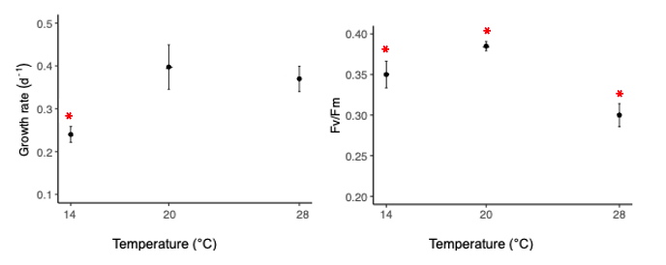
Figure 1. Average growth rate (left) and photosynthetic efficiency (right) of E. huxleyi when acclimated at 14°C, 20°C, and 28°C. Error bars represent the standard deviation between replicates. Asterisks (*) represent statistically significant differences (p < 0.05). Adapted from Powers, (2023).

- Metabolomics Methods, Results, and Discussion
E. huxleyi cells were collected during late-exponential phase onto 2.0 μmol pore-size filters and stored at -80°C until processing. Before shipment for metabolomic analysis, the filters were thawed for washing, transferred into microcentrifuge tubes, then centrifuged to cell pellets. The pellets were sent on dry ice to the DOE Joint Genome Institute (JGI) for endometabolite identification using their LC-MS metabolomics pipeline. Both negative and positive ionization modes were used to detect metabolites. The MS/MS similarity, retention time, and m/z ratio of metabolites present in each sample were compared to standards in JGI’s database to identify and quantify metabolite presence. The peak height values of the identified endometabolites were normalized to cell biovolume and were used as a proxy for concentration in subsequent analysis.
The raw data files for both positive and negative ionized targeted mass spectrometry were imported into RStudio and reformatted for subsequent analysis. The three control peak height values for each metabolite were averaged and subtracted from each temperature treatment’s peak height value to remove background signals. From there, the metabolites that had at least three out of four replicates with positive peak height values in each temperature treatment moved on for further statistical analysis. From these replicates with positive peak height values, the peak heights were averaged for and the standard deviation between replicates were calculated for each temperature and metabolite. A one-way ANOVA test was performed on each metabolite to determine p-values between all three temperature treatments, and these were corrected with the Benjamini-Hochberg procedure to decrease the false discovery rate. Metabolites with significant corrected p-values (p < 0.05) were run through a Tukey’s Honest Significant Different (HSD) test to determine significant differences in peak heights between paired temperature treatments.
A total of 109 endometabolites produced by E. huxleyi were identified through targeted LC-MS, but only 9 were found to have significant differences between temperature treatments (Figure 2). Exact p-values between temperature treatments are organized in Table 1. Mannitol and sorbitol have identical data because they are isomers having the same molecular formula and weight with just a different orientation of one bond (Table 3), and therefore difficult to differentiate in the LC-MS analysis.
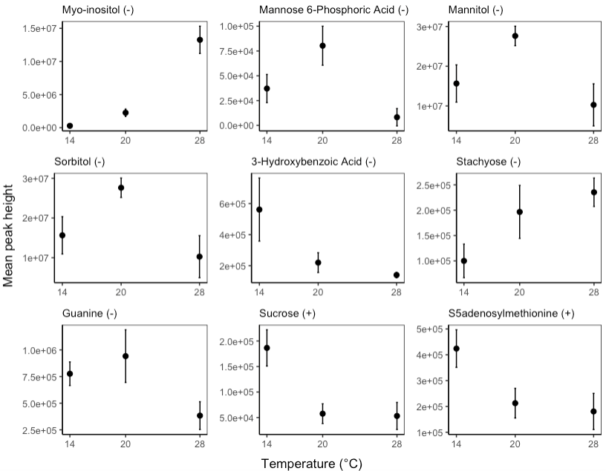
S-(5'-adenosyl)-methionine (+)
*
*
*
*
*
*
*
*
*
*
*
*
*
*
*
*
*
*
Figure 2. Mean peak heights of the 9 endometabolites out of 100 produced by E. huxleyi identified by the targeted LC-MS that had significant differences between temperature treatments based on an ANOVA (p < 0.05). The (-) and (+) next to each endometabolite name denote the ionization mode of detection from the mass spectrometry. Error bars represent the standard deviation between replicates. Red stars (*) represent statistically significant differences (p < 0.05) between paired temperature treatments for each metabolite based on the Tukey’s HSD test.

Table 1. P-values from the Tukey’s HSD test between paired temperature treatments for each metabolite. Values in red are statistically significant (p < 0.05).

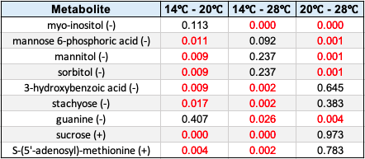

In the 14°C treatment, concentration was significantly higher for 3-hydroxybenzoic acid (3HBA), S-(5’-adenosyl)-methionine (SAM), and sucrose and significantly lower for stachyose (Table 2). 3HBA is an aromatic acid and a signaling molecule within the cell, and evidence suggests it stimulates cell growth, improves ATP production, and positively impacts carbon assimilation (Fu et al., 2021). SAM is an organosulfur compound that donates a methyl group for the methylation of lipids, proteins, and nucleic acids (Ye et al., 2018). Since the 14°C treatment had the lowest growth rate (Figure 1), a high concentration of 3HBA and SAM may have been related to promoting growth and development of the cells.
Sucrose is a disaccharide sugar and stachyose is a tetrasaccharide sugar, which are involved in the storage of carbon and energy in cells (Table 2). Sucrose has also been found to alleviate cold stress in plants, so its accumulation in the E. huxleyi cells may be to enhance the tolerance to cold temperatures (Nagao & Uemura, 2012). Cells accumulate monosaccharides and disaccharides during cold acclimation, such as sucrose, but do not accumulate trisacharrides and tetrasaccharides, such as stachyose, which may explain the low concentration of stachyose in the 14ºC E. huxleyi cells (Nagao et al., 2008). The differences between sucrose and stachyose concentrations may be indicative of production of more simple sugars instead of more complex sugars to save energy during acclimation to cold temperatures.

Table 2. Endometabolites produced by E. huxleyi that were statistically significantly different in the 14°C treatment when compared to the 20°C and 28°C treatments.

Metabolite | Difference | Structure | Classification | Role
3-hydroxybenzoic acid (3HBA) | Higher | 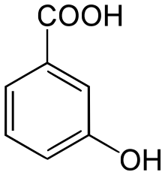 | Benzoic acid | Signaling molecule  (Fu et al., 2021)
S-(5’-adenosyl)-methionine (SAM) | Higher | 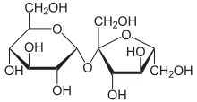 | Organosulfur compound | Methyl donor  (Ye et al., 2018)
Sucrose | Higher | 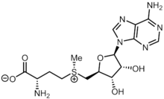 | Disaccharide sugar | Carbon and energy
Stachyose | Lower | 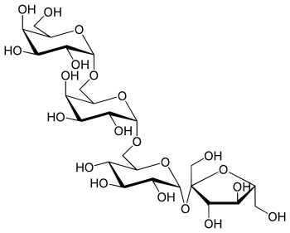 | Tetrasaccharide sugar | Carbon and energy

Mannitol, sorbitol, and mannose 6-phosphoric acid (M6P) had significantly higher concentrations in the 20°C treatment (Table 3). Since mannitol and sorbitol are isomers and were possibly not able to be differentiated in the LC-MS process, they were grouped together in the table. Mannitol and sorbitol are sugar alcohols, so they are involved in the storage of carbon and energy within the cell. Because the E. huxleyi cells were growing at a temperature within their preferred range, they may not have had an immediate need for carbon storage. Mannitol and sorbitol are also major photosynthetic products, which may have accumulated to a higher concentration due to the high photosynthetic efficiency in this temperature treatment (Figure 1). M6P is an organophosphorus compound and an important precursor to mannitol in the mannitol synthesis pathway (Loescher et al., 1992). Since mannitol concentrations were high, high concentrations of M6P might therefore be necessary to support mannitol synthesis.

Table 3. Endometabolites produced by E. huxleyi that were statistically significantly different in the 20°C treatment when compared to the 14°C and 28°C treatments.

Metabolite | Difference | Structure | Classification | Role
Mannitol/  Sorbitol | Higher | 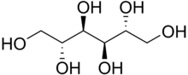 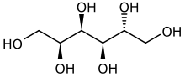 (Isomers) | Sugar alcohols | Carbon and energy;  photosynthetic products  (Iwamoto & Shiraiwa, 2005)
Mannose 6-phosphoric acid (M6P) | Higher | 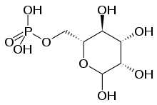 | Organophosphorus compound | Precursor in mannitol synthesis  (Loescher et al., 1992)

In the 28°C treatment, myo-inositol had a significantly higher concentration and guanine had a significantly lower concentration than in the 14°C and 20°C treatments (Table 4). Myo-inositol is a sugar alcohol, so it is involved in carbon and energy storage, but it is also involved in other growth and development processes such as hormone signaling, synthesis of structural supports, and stress tolerance (Qiao et al., 2021). 28°C is warmer than E. huxleyi’s preferred range of 20-25°C and warmer than 27°C, which has been observed as the maximum temperature of increased growth in E. huxleyi (Fielding, 2013). A low photosynthetic efficiency (Figure 1) and high concentration of myo-inositol may indicate that the E. huxleyi cells were stressed at this warm temperature. The accumulation of myo-inositol was potentially necessary to alleviate heat stress and promote growth and development.
Guanine is a purine nucleobase, which is a major component of DNA and RNA. It has also been found to be important in nitrogen storage in cells (Mojzeš et al., 2020). Nitrogen stimulates growth and positively affects metabolism within phytoplankton cells, so the E. huxleyi cells may have depleted this source of nitrogen during growth while stressed at a high temperature. Low concentrations of nitrogen cause a reduction of photosynthesis, which is reflected in the low photosynthetic efficiency in the 28°C treatment (Figure 1). Nitrogen shortages also cause an accumulation of carbon and energy rich, nitrogen-free compounds, which may also explain the high concentration of myo-inositol in this temperature treatment.

Table 4. Endometabolites produced by E. huxleyi that were statistically significantly different in the 28°C treatment when compared to the 14°C and 20°C treatments.

Metabolite | Difference | Structure | Classification | Role
Myo-inositol | Higher | 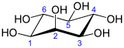 | Sugar alcohol | Carbon and energy; growth and development;  stress tolerance  (Qiao et al., 2021)
Guanine | Lower | 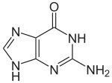 | Purine nucleobase | DNA and RNA;  nitrogen storage (Mojzeš et al., 2020)

- Conclusion
Nine endometabolites, out of 109 total identified endometabolites produced by E. huxleyi, had significant differences in concentration between temperature treatments. The endometabolites that were significantly different in 14°C treatment compared to the 20°C and 28°C treatments may change in concentration due to growth processes and acclimation to a cold temperature (Table 2). The E. huxleyi cells were most likely not stressed at 14°C because they have been observed growing normally at 2-27°C and 14°C is this strain’s maintenance temperature. Significantly different endometabolites in the 20°C treatment may be related to carbon storage and a high photosynthetic efficiency (Table 3). The 20°C treatment had a high growth rate and a significantly higher photosynthetic efficiency compared to the 14°C and 28°C treatments (Figure 1), which was most likely due to being grown in their preferred temperature range of 20-25°C. More carbon storage may have been necessary since energy was not immediately needed for growth and high photosynthetic efficiency, and could have led to the accumulation of more photosynthetic products. The endometabolites significantly different in the 28°C treatment may have had different concentrations due to thermal stress (Table 4). E. huxleyi growth rates decline after 27°C, most likely due to heat stress, which may be indicated by the low photosynthetic efficiency in the 28°C treatment (Figure 1). Accumulation of an endometabolite that promotes stress tolerance and nitrogen storage may also indicate a stress response due to a high temperature in the E. huxleyi cells.
As of now, not much is known about the roles of specific endometabolites in phytoplankton physiology and how their concentrations will change in the future due to climate change. Most of the studies cited in the discussion were centered on plants or algae as a group, not specifically on phytoplankton or E. huxleyi. From these results, it was determined that endometabolite pools change in response to temperature acclimation in E. huxleyi, which may have a broader impact on marine ecosystems and processes. Anthropogenic climate change has caused an increase in sea surface temperatures, which may lead to stress and different concentrations of metabolites in E. huxleyi and other phytoplankton. The organisms that rely on the materials produced by phytoplankton may be affected by this change in physiology, and the biogeochemical cycles that they are a part of may be affected as well. How such changes will manifest will depend on regional communities and climates, as phytoplankton like E. huxleyi are adapted to their local conditions (Zhang et al., 2014). To develop an understanding of the global response of phytoplankton physiology to climate change, multiple strains of each species should be studied to address their diversity and regionality. With this information, more insight into how global sea surface communities and processes will be affected due to climate change will be available.

- References
Barton, A. D., Irwin, A. J., Finkel, Z. V., & Stock, C. A. (2016). Anthropogenic climate change drives shift and shuffle in North Atlantic phytoplankton communities. Proceedings of the National Academy of Sciences. 113(11): 2964-2969.

Buchan, A., LeCleir, G. R., Gulvik, C. A., & González, J. M. (2014). Master recyclers: features and functions of bacteria associated with phytoplankton blooms. Nature Reviews Microbiology. 12(10): 686-698.

Castberg, T., et al. (2001). Microbial population dynamics and diversity during a bloom of the marine coccolithophorid Emiliania huxleyi (Haptophyta). Marine Ecology Progress Series. 221: 39-46.

Daniels, C. J., Sheward, R. M., & Poulton, A. J. (2014). Biogeochemical implications of comparative growth rates of Emiliania huxleyi and Coccolithus species. Biogeosciences. 11(23): 6915-6925.

Emiliania huxleyi. Bigelow NCMA. https://ncma.bigelow.org/CCMP2090

Fielding, S. R. (2013). Emiliania huxleyi specific growth rate dependence on temperature. Limnology and Oceanography. 58(2): 663-666.

Fu, L., et al. (2021). Benzoic and salicylic acid are the signaling molecules of Chlorella cells for improving cell growth. Chemosphere. 265: 129084.

Iwamoto, K., & Shiraiwa, Y. (2005). Salt-regulated mannitol metabolism in algae. Marine Biotechnology. 7: 407-415.

Loescher, W. H., Tyson, R. H., Everard, J. D., Redgwell, R. J., & Bieleski, R. L. (1992). Mannitol synthesis in higher plants: evidence for the role and characterization of a NADPH-dependent mannose 6-phosphate reductase. Plant Physiology. 98(4): 1396-1402.

Mathur, S., Agrawal, D., & Jajoo, A. (2014). Photosynthesis: response to high temperature stress. Journal of Photochemistry and Photobiology B: Biology. 137: 116-126.

Mojzeš, P., et al. (2020). Guanine, a high-capacity and rapid-turnover nitrogen reserve in microalgal cells. Proceedings of the National Academy of Sciences. 117(51): 32722-32730.

Nagao, M., Matsui, K., & Uemura, M. (2008). Klebsormidium flaccidum, a charophycean green alga, exhibits cold acclimation that is closely associated with compatible solute accumulation and ultrastructural changes. Plant, Cell & Environment. 31(6): 872-885.

Nagao, M., & Uemura, M. (2012). Sucrose phosphate phosphatase in the green alga Klebsormidium flaccidum (Streptophyta) lacks an extensive C-terminal domain and differs from that of land plants. Planta. 235: 851-861.

Paasche, E. (2001). A review of the coccolithophorid Emiliania huxleyi (Prymnesiophyceae), with particular reference to growth, coccolith formation, and calcification photosynthesis interactions. Phycologia. 40(6): 503-529.

Powers, M. (2023). Investigating the response of marine bacterial communities to shifts in phytoplankton derived metabolite pools. Dissertation Prospectus, University of Georgia.

Qiao, T., et al. (2021). Myo-inositol promotes lipid production and nutrients removal by microalga under molasses wastewater. Renewable Energy. 172: 327-335.

Rosas-Navarro, A., Langer, G., & Ziveri, P. (2016). Temperature affects the morphology and calcification of Emiliania huxleyi strains. Biogeosciences. 13(10): 2913-2926.

Ye, C., Sutter, B. M., Wang, Y., Kuang, Z., & Tu, B. P. (2017). A metabolic function for phospholipid and histone methylation. Molecular Cell. 66(2): 180-193.

Zhang, Y., Klapper, R., Lohbeck, K. T., Bach, L. T., Schulz, K. G., Reusch, T. B., & Riebesell, U. (2014). Between‐and within‐population variations in thermal reaction norms of the coccolithophore Emiliania huxleyi. Limnology and Oceanography. 59(5): 1570-1580.

