**Examining Fine-Scale Larval Fish Patterns Using In-Situ Imagery Coupled with Oceanographic Measurements in the Northern Gulf of Mexico.**

Severen E. Brown

University of Georgia, Marine Sciences

Double Dawgs Program

April 2022

Internship report submitted as part of the requirement for the Franklin College Master of Science degree in:

*Master of Sciences in Marine Sciences*

*(Non-Thesis)*

Approved By: ____________________________________ Date: ____\_____\_______

Adam T. Greer (Advisor)

Approved By: ____________________________________ Date:____\_____\_______

Amanda C. Spivak (Committee Member)

Approved By: ____________________________________ Date: ____\_____\_______

Brain M. Hopkinson (Committee Member)

Dean: __________________________________________ Date: ____\_____\_______

**Abstract:**

Describing larval fish abundance and distribution on fine spatial scales can help us understand how they are responding to their environment. Traditionally, plankton net tows have been used to study larval fishes, but these samples do not indicate where the fish were originally aggregated in the water. The objective of the study is to understand how varying degrees of river influence and contrasting oceanographic environments have influenced larval fish distributions at the family level on a fine scale. This observational study utilized a towed instrument package, the In Situ Ichthyoplankton Imaging System (ISIIS), which measured physical oceanographic variables connected to the abundance and distribution of larval fishes and other zooplankton, capturing a snapshot of the environmental conditions which the larval fishes experience. The data collection took place in the Gulf of Mexico. Regions of interest (ROIs) for particles above 2000 pixels in size or 3.0 mm Equivalent Spherical Diameter (ESD) were extracted automatically, and larval fish were manually removed and sorted to the lowest taxonomic level possible. Differences in the larval fish communities and distributions were apparent among the three different corridors sampled: one with low riverine influence serving as an “environmental control group”, (ECORR) one with a medium amount of riverine influence (MCORR) and one with a high level of riverine influence (WCORR) and widespread hypoxia (dissolved oxygen < 2.0 mg/L). Larval fishes from the family Engraulidae were found to aggregate near the surface, while other families such as Bregmacerotidae and Synodontidae had a propensity for deeper and more saline water. Engraulids in the DAY transects aggregated near the thermoclines and haloclines. Going forward it may be possible to use the larvae positions in the water column as particles to track dispersal patterns. Aggregations and oceanic current information could be used in conjunction with the pelagic larval duration (PLD) to extrapolate spawning locations.

**1. Introduction**:

The foundation of a productive fishery is rooted in the health of the forage fish population. Forage fish such as anchovies of the family Engraulidae are at the intermediate trophic step between planktonic organisms such as copepods and phytoplankton, and higher trophic level apex predators (Rivers et al. 2022). Tuna and grouper commercial fisheries, as well as recreationally fished tarpon, are dependent on the forage fish for survival. Researchers know very little about forage fish dynamics on near shore continental shelves. Most studies describing forage fish behavior occur in outer shelf, oceanic, or estuarine locations. A comparatively small amount of information documents forage fish behavior in the inner continental shelf (Rivers et al. 2022). Both the highly dynamic environmental factors which regulate primary production and the aggregation of forage fish can be observed at a fine scale. Low oxygen events, ocean acidification, and eutrophication as a result of riverine influence can all be tracked and monitored on the inner shelf (Dzwonkowski 2015). The inner shelf also “includes locations often targeted for conservation measures, such as marine reserves and protected areas” which could greatly impact forage fish stock numbers (Rivers et al. 2020). Continued research will allow researchers to model the system more accurately and thus understand the entire ecosystem from phytoplankton to upper level trophic predators more completely.

The northern Gulf of Mexico (nGOM) fisheries contribute millions of dollars to the economy through recreational and most importantly, commercial fishing. Gordon Gunter coined the term “fertile fisheries crescent” with regard to the nGOM and this study indeed exhibits both great variety and abundance of fish in the nGOM. (Burke, 1999). A knowledge gap remains surrounding how oceanographic processes influence the early life stages of fish. The studies which do have data from this region usually fall into two categories: adult fish stock studies where researchers are only concerned about mature fish which are of breeding age (for sustainable yield studies) and net studies of larval fish (Ditty 1999). Adult fishery information on a broad scale has already been well established by commercial ventures and studies conducted by agencies such as National Oceanographic and Atmospheric Administration (NOAA). Ships “conduct a variety of fisheries, plankton and marine animal surveys in the Gulf of Mexico.” (NOAA) Understanding where larval fish reside will tell researchers where important nursery grounds are, and what physical conditions are present in that region of the nGOM

One oceanographic property that is both influenced by life at the microbial level and influences fishes from all life stages is dissolved oxygen. When waters become depleted of dissolved oxygen the phenomenon is known as hypoxia. (Roman, 2019) Hypoxia is generally defined as water having less than 2 parts per million of dissolved oxygen. (Roman, 2019) Fish and other mega fauna have a difficult time surviving in these conditions in the nGOM, which is why a hypoxic zone is colloquially known as a “dead zone.” The term “dead zone” can be misleading since many species of bacteria can survive in these harsh environments, the term instead refers to the low abundances of life targeted by fisheries. (Rabalais , 2002) Hypoxia is caused by overgrowth of phytoplankton due to excess nutrient input from local rivers that leads to oxygen depletion when they die and are decomposed by microorganisms, and is most severe in the summer. (Roman, 2019). The summer hypoxic zone occurs on the shallow coastal shelf spans from Texas to Louisiana in the northern Gulf of Mexico and each summer the size of this region is measured as part of a NOAA study (NOAA). During the summer, a freshwater lens over the bottom waters causes very little mixing to occur and thus bottom waters become hypoxic due to the strong thermocline isolating deeper water. (Dzwonkowski et al. 2018). Hurricanes in the gulf can help mix the gulf and redistribute dissolved oxygen in the gulf mixing and re-oxygenating bottom water, whereas floods can make the nutrient driven phytoplankton bloom even more severe. (Dzwonkowski et al. 2018).Higher riverine influence generally correlates to a larger hypoxic zone in the gulf due to a higher influx of nutrients from upstream. High levels of nutrients cause phytoplankton blooms to occur in the nGOM and when these blooms die rapidly, the microbial respiration from the degradation of the phytoplankton biomass quickly depletes the oxygen in the area (Rabalais 2019).

Very little is known about fine scale disturbances and aggregations of fish in the Gulf of Mexico. Satellite studies of sea surface temperature and chlorophyll-a measurements can only provide a rough idea about surface primary productivity. Fish are operating on a much smaller scale compared to what can be gained from a satellite measuring parameters on the km scale. Oceanic fronts at the boundary of different water masses, vertically compressed thin layers, and diel vertical migration are just some of the small scale features that can be observed with the ISIIS (Greer, 2013, 2015). The knowledge gap about where aggregations, predation, migration, and spawning occur on scales which larval fish operate within can be addressed with further studies on a small scale. The knowledge gap, once addressed, may be able to inform researchers about how to better preserve or bolster fisheries in the nGOM. Transects of this study passed through hypoxic regions and fine scale interactions between the larval fish families and the hypoxic regions were able to be documented. (Figure 1)

Larval fish have been studied via Plankton Net Tows; however, it is impossible to tell where the fish were aggregated or where in the water column the fish originated. New imaging techniques such as the In Situ Ichthyoplankton Imaging System (ISIIS) coupled with physical oceanographic data allow a more complete picture of the environment fish larvae actually experience. The ISIIS system captures individual larval fish in their natural environment and orientation whereas nets sampling bin larval fish together and remove them from their natural environment for analysis. This system was specifically designed to be used in ichthyoplankton studies since the vehicle is towed at a high speed and accommodates a large volume of water (Cowen 2008). The ISIIS is a remotely operated towed vehicle since it is physically attached to the ship (in contrast to a ROV which is untethered). The ISIIS and plankton net tows can be used in conjunction to examine, categorize, and make comprehensive inferences about larval fish in the nGOM. (Greer et al. 2018)

**1.1 Knowledge Gaps:**

The first knowledge gap that was addressed with the data was how hypoxia affects larval fish aggregation. It is unknown how larval fish respond to the hypoxic bottom waters in the nGOM. It is possible that certain families will be more tolerant to bottom waters than others. Additionally, it is unknown if abundances will be lower in these hypoxic regions. It is possible that abundances will remain high in areas with hypoxia if larval fish aggregate in the top of the water column. More larval fish in a vertically compressed habitat will create regions with extremely high density if this is observed.

The second knowledge gap that will be addressed is if there will be evidence of diel vertical migration will be seen in the fine scale in-situ imagery data. Diel vertical migration occurs when fish move vertically in the water column during a 24 hour period. It is hypothesized that fish move up in the water column during the night and avoid predators that are more adept at hunting visually during the day time. In pelagic environments this migration can occur over a spatial scale of hundreds of meters. In the inner shelf environment of the nGOM this proposed migration would be at a very fine scale. The shelf environment is a maximum of 30 meters deep, meaning any vertical migration taking place would need to be observed on a small scale. Though the inner shelf environment is only 30 meters at its deepest, the habitat is very heterogeneous due to the strong thermocline, especially present in the summer months. The high level of freshwater input, high turbidity water and hypoxic bottom water all pose reasons for larval fish to migrate vertically to different habitats in the water column.

The last knowledge gap that will be addressed with the ISIIS data set is if there will be fine scale oceanographic features in the study site and how these areas affect larval fish distributions. Internal waves, surface convergences, and the thermocline, halocline or pycnocline are all small scale features that would be possible to observe with the ISIIS system. It is possible that these features may coalesce planktonic organisms and thus be a favorable habitat for larval fish. These areas may also concentrate predators of larval fish and avoidance may be seen with regards to these small scale oceanic anomalies. The identities of families and in what abundances they aggregate can be addressed with in situ imagery.

**2 Methods**

**2.1 Imaging System**

The In Situ Ichthyoplankton Imaging System (ISIIS) is an imaging system towed behind a research vessel and was used to record larval fish species in the Northern Gulf of Mexico. (Greer, 2018) The ISIIS apparatus undulates in the water column from the surface to ~2m from sea floor while being towed with the utilization of motor actuated fins while continually scanning a 50 cm depth of field and 12cm field of view (2048 pixels). (Cowen, 2008) The Piranha II line scan camera (Dalsa) scans the water parcel at a rate of 36,000 images per second. (Greer, 2017) The line scan camera operates by projecting parallel light across the 50cm depth of field, plankton then blocks this light, thereby creating a silhouette image which the camera captures. Body parts of the larval fish such as eyes and the gut are opaque, but fin rays and musculature can be transparent due to the brightness of the light. 1 cubic meter of the ocean is sampled every 7.7 seconds at a typical 2.5 meter per second tow speed (Greer et al. 2018). The ISIIS simultaneously records velocity, conductivity, temperature, and depth while imaging. These measurements were collected with the following equipment; salinity, temperature, and depth (Sea-Bird Electronics 49 FastCAT), dissolved oxygen (SBE 43), chl a fluorescence (Wet Labs FLRT), and photosynthetically active radiation (PAR; Biospherical QCP-2300). Image and sensor data were transmitted through fiber optic cable to onboard computers for recording (CONCORDE).

**2.2 Sampling Scheme**

The ISIIS was towed behind the *RV Point Sur* (owned and operated by the University of Southern Mississippi)(Greer, 2020, CONCORDE). The CONsortium for oil exposure pathways in COastal River-Dominated Ecosystems (CONCORDE) was responsible for the sampling scheme and data handling in 2016. The CONCORDE group was “designed to identify and quantitatively assess key physical, biological, and geochemical processes acting in the nGOM, in order to provide the foundation for implementation of a synthesis model (coupled circulation and biogeochemistry) of the nGOM shelf system” (Greer et al. 2018, CONCORDE) Three ~60 km meridional transects were performed as a series in the nGOM, oriented from the north toward the south. The western corridor (WCORR) was conducted on July 24th 2016, the middle corridor (MCORR) on July 25th, 2016, and the eastern corridor (ECORR) on July 26, 2016 (CONCORDE 2018). The corridors were specifically chosen to show a varied amount of riverine influence. Additionally, two day/night transects were performed in triplicate. The NIGHT transects were collected on July 28, 2016 (three repete transects performed immediately after one another) and the DAY corridor was collected on July 29, 2016 (Three transects performed in succession) (CONCORDE 2018). These transects were specifically chosen to observe differences in fish aggregation during the day and night and quantify diel vertical migration.

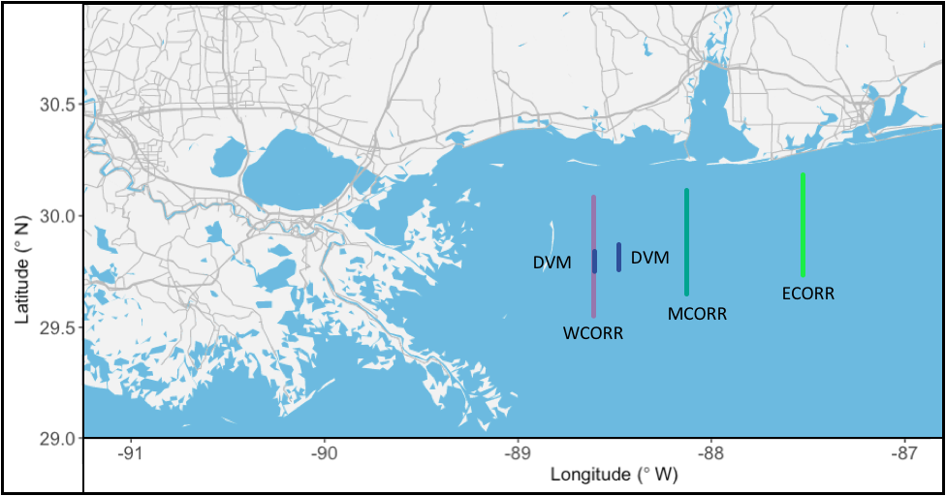

**Figure 1.** Sampling map of the study. WCORR was conducted on July 24, MCORR on July 25, and ECORR on July 26, 2016. The NIGHT and DAY transects were conducted on July 28th and 29th respectively.

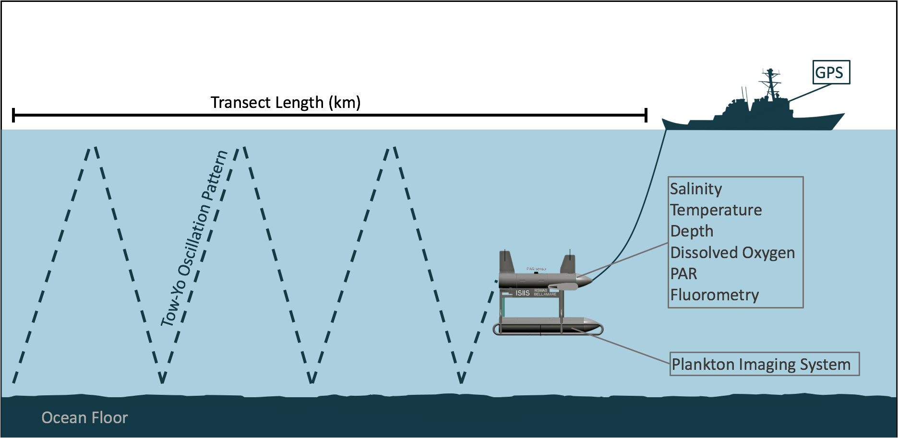

**Figure 2.** The ISIIS acts as a yo-yo as it is towed through the water column at 2.5 meters per second. This pattern allows the CTD and imaging system to gather highly detailed in situ data.

**2.3 Plankton net trawls**

A Bedford Institute of Oceanography Net Environmental Sampling System (BIONESS; Open Seas Instrumentation) was deployed behind the research vessel at the beginning and the end of each transect to capture larval fish which were used to verify ISIIS image classifications and develop the ISIIS image library.

**2.4 Image Processing**

Images were first analyzed with the use of ImageJ software (version 1.52v, Schneider et al. 2012) and Preview (macOS, 2021). The images undergo a flat-fielding procedure to remove background noise and artifacts. A threshold of 170 pixel gray level is used to delineate particles. (Greer, 2020)Pixels under 170 gray values are considered white and any pixels above this gray value are considered back. These processed images will be segmented (i.e., regions of interest (ROIs) are extracted) for particles above 2000 pixels in size or 3.0 mm Equivalent Spherical Diameter (ESD). The larval fishes are manually removed from a set of a few hundred thousand ROIs for each transect. Larvae are then identified to the lowest taxonomic level possible (typically family level). Plankton net tows were used as a basis of comparison for the ISIIS data since researchers can examine familial identities on real fish before applying this to the imagery data. The images were sorted into approximately 30 taxonomic familial groups, though some groups had very few, if any, samples in each transect.

**2.5 Data Analysis**

Each image contained a time stamp in the image file name. Environmental data was also recorded with a timestamp and image files were able to be merged with environmental data with the use of R studio and R (v.4.1.2, R Core Team 2021). Both time stamps were converted into a percentage of the day (julian timestamp) and images were merged to the closest environmental data collected with R code. The categorized groups were plotted against various environmental conditions and visualized with ggplot2. A variety of plots were created as demonstrated in the results sections.

**2.6 Timeline**:

The timeline of the research project was from June 1st 2020 to May 2022. During the first three months of the project the Eastern Corridor, Middle Corridor, and Western Corridor larval fish regions of interest were categorized into taxonomic family folders. The folders were then refined and plots were created to graphically represent the larval fish aggregations. On October 30, 2020, findings were presented to the UGA Marine Sciences department by Severen Brown during a coffee hour meeting. The Day and Night corridor region of interests were then manually sorted by the presence of fish and were subsequently taxonomically sorted as well. The final project report for the Non-Thesis presentation will be submitted by the end of April 2022.

**3 Results**

**3.1 Taxonomic Family Delineation:**

The regions of interest which were denoted as fish were able to be separated into 30 categories, though some folders had as few as one individual of that family. Two of these categories were determined to be “other” and “unsure.” The “Other” category contains images that at first were thought to be fish when sorted from all the images the program selected, but have since been re-examined and determined to not be fish. The “unsure” category continues images that are clearly fish but are unable to be identified due to the crop, blur, grain, or orientation of the image. The remaining categories are as follows: Balistidae, Bregmacerotidae, Chetodnath, Engraulidae, Pleuronectidae, Gobiidae, Leptocephalus, LongerWrasse, Lutjanidae, Microdesmedae, Ophidiid, Pipefish, PointyNose, Polychete, Round, ScaridaeWrasse, Scombradae, Scorpaniadae, Serranidae, Shrimp, SmallFinHead, Stromateidae, Synodontidae, Thin and Pointy, Tinophore, Trichuridae, Triglidae, Very Lobed. It is recognized that some of these categories are not fish (Chetodnath, Polychete, Shrimp, Tinophore). Additionally, some folders that have strong resemblances were not able to be taxonomically identified to the familial level ( LongerWrasse, PointyNose, Round, SmallFinHead, Thin and Pointy, Very Lobed).

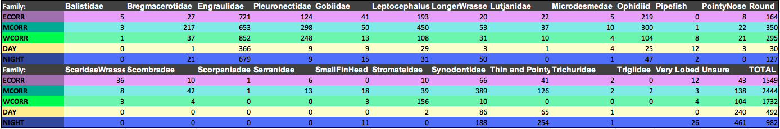

**Figure 3:** Displaying counts of all taxonomically identified fish families from each corridor. “Unsure” category is included since the images are clearly fish, just unidentifiable.

The total abundances of larval fish for each corridor are as follows: ECORR: 1549, MCORR: 2444 and WCORR: 1732 in approximately 60,000 cubic meters. DAY 492 and NIGHT: 982 in approximately 10,000 cubic meters. The most abundant category of larval fish in each of the transects is Engraulidae (anchovies), making up 50-75 percent of the community in the WCORR, DAY and NIGHT transects. The DAY and NIGHT transects have less total fish due to the transects being shorter in length (Figure 1). The “Unsure” category is typically numerous as the images are often grainy, cropped in half during the segmentation process, or in an orientation that makes it difficult to determine the family such as imaged from head on. Often it is impossible to identify an image more closely than knowing that it is a fish of some undetermined variety from evident fin rays.

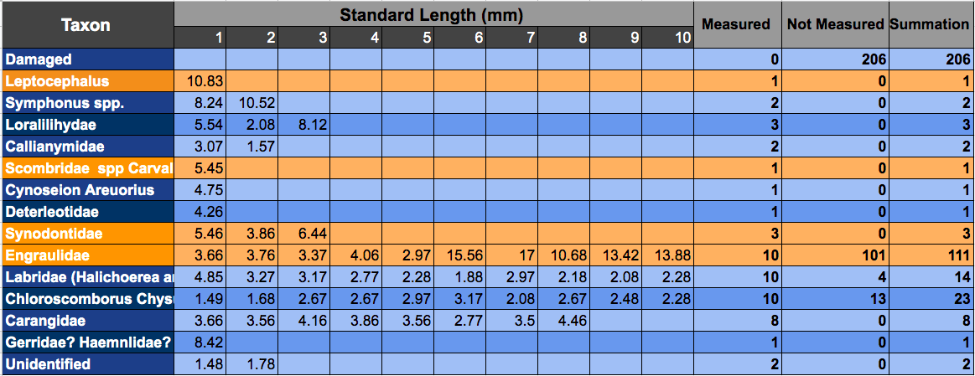

**Figure 4.** Selected net trawl data from July 28, 2016 using 335 μm mesh in the nGOM. Samples were sorted on September 17, 2017. Orange boxes indicate families that were taxonomically identified with the ISIIS.

Figure 4 is an image of a net sampling sheet that was used on the *RV Point Sur* on the same day the NIGHT transect was sampled. These net tow sheets were compared with the taxonomically sorted finding to determine the validity of the categorization. It is often difficult to determine the family of a fish from the silhouette picture the ISIIS captures. The net tow sheets were instrumental in corroborating findings.

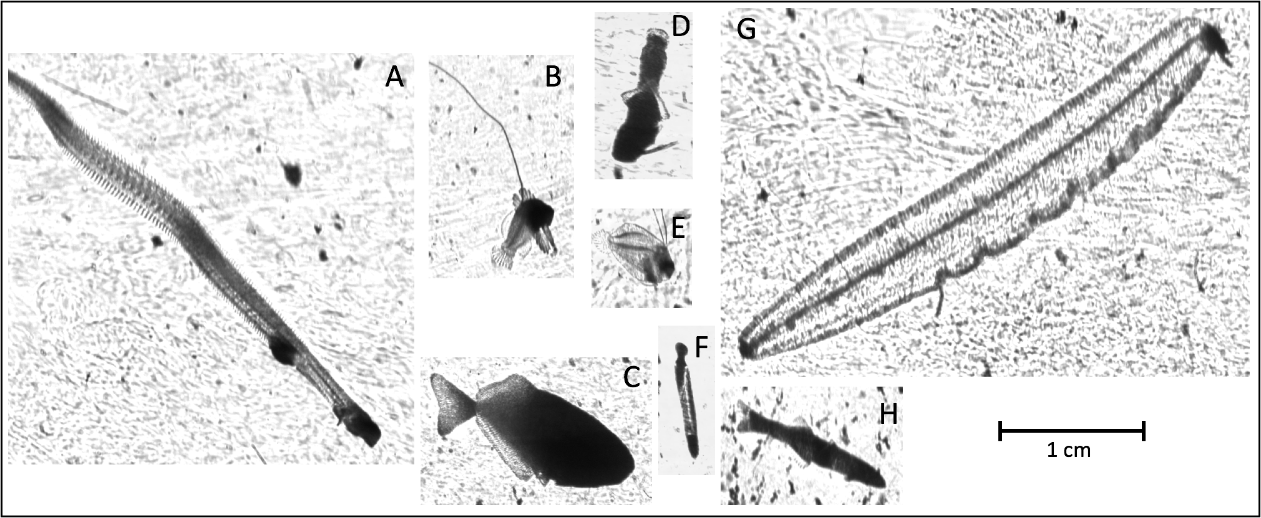

**Figure 5**. In Situ Fish Images 0-40 meters in depth, ECORR transect. Fish are to scale (1cm scale bars shown).Fish taxa captured: **A**. Ophidiid, **B.** Serranidae**, C:** Stromateidae, **D.** Bregmacerotidae, **E.**Pleuronectiformes, **F**:Synodontidae, **G**.Leptocephalus, **H**. Gobiidae

Figure 5 displays seven of the most common larval fish families out of the 30 that were identified. Images are displayed in their true orientation (surface of the ocean toward the top of the figure). The ISIIS ROTV captures these images moving from the left of the figure to the right of the figure. All of the images are scaled to the 1 centimeter bar in the bottom right of the figure.

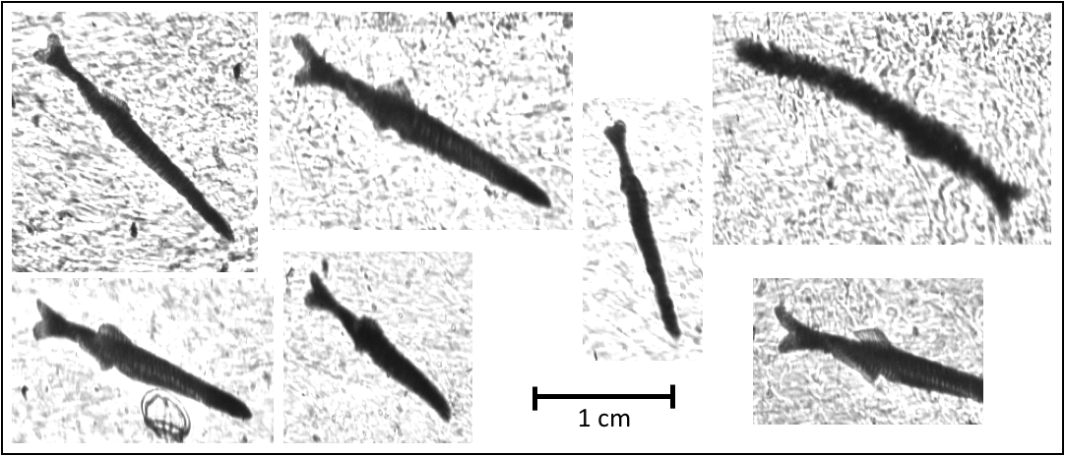

**Figure 6**. Engraulidae (anchovy) In Situ Fish Images 0-40 meters in depth, DAY transect. Fish are to scale (1cm scale bars shown)

Figure 6 displays a variety of Engraulidae larvae images. Images are displayed in their true orientation (surface of the ocean toward the top of the figure). Images to the left of the figure are examples that are clear and easy to identify regions of interest. Images on the right are examples of blurry or cut off images that were seen in the data.

**3.2 Graphical Representation:**

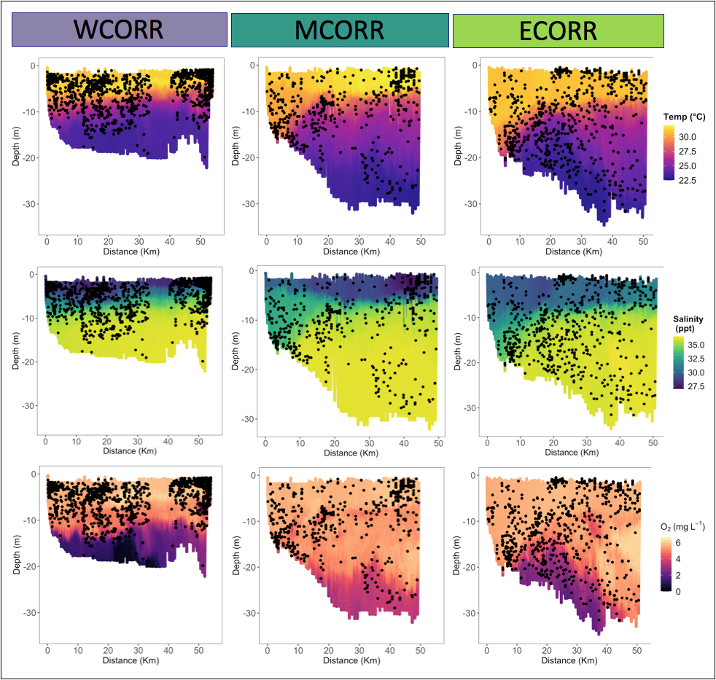

**Figure 7**. Engraulidae family larval fish plotted with temperature (°C), salinity (ppt) and Dissolved oxygen (mgL-1 O2 ) for western corridor (WCORR), middle corridor (MCORR), and eastern corridor (ECORR) Each dot represents one individual, more heavily pigmented regions indicate aggregations of Engraulidae. WCORR contains a 7km gap in data due to particulate matter in the water column making the segmentation program work improperly due to low contrast between the particles and the background. (30km - 37km)

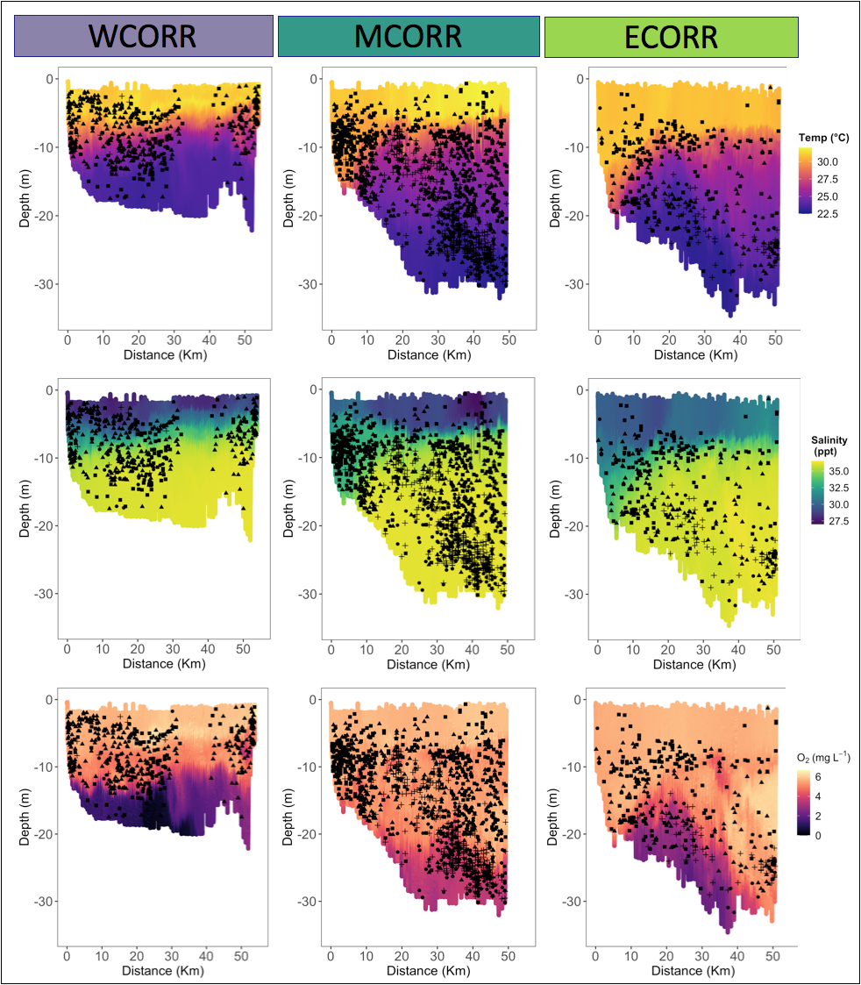

**Figure 8**: 4 larval fish families plotted with temperature (°C), salinity (ppt) and Dissolved oxygen (mgL-1 O2 ) for western corridor (WCORR), middle corridor (MCORR), and eastern corridor (ECORR). Shapes represent different family taxa: Bregmacerotidae, Pleuronectiformes, Leptocephalus,Synodontidae. WCORR contains a 7km gap in data due to particulate matter in the water column making images indistinguishable (30km - 37km)

**4.1 Western Corridor**

The western corridor (WCORR), conducted on July 24th, was found to be the most hypoxic of all the corridors (figure 9) with an average value of 4.15 mgL-1 O2  which is only just above the definition of hypoxic waters at 2 mgL-1 O2. The WCORR contained a 7km gap where it was impossible to categorize the larval fish data into familial bins. In this 7km region there was a large amount of particulate matter in the water column that made the images from the silhouette camera on the ISIIS impossible to distinguish. Assuming this 7km region contained similar fish density to the rest of the corridor, it is safe to say that the WCORR had the highest density of fish. Additionally, the WCORR has the least vertical habitat of all the corridors. The WCORR had a maximum depth of 20m as opposed to 30 and 35 meters for the MCORR and ECORR respectively. (Figure 7,8) Fish also tend to avoid the hypoxic habitat (Figure 7,8) meaning their functional habitat is vertically compressed. In summary the WCORR is clearly capable of supporting higher abundances potentially due to the high level of riverine influence and potential for phytoplankton blooms. The high amount of riverine influence is a factor in increased risk of hypoxia, yet also makes for an incredibly dense larval fish environment.

**4.2 Middle Corridor**

The middle corridor, conducted on July 25, was found to have a very high fish count of 2444 individuals. This was the highest of all the corridors when the missing section of the WCORR is not taken into account. The MCORR has a large vertical habitat for fish due to the depth and the well oxygenated water all the way to the benthic environment. Very little of the middle corridor experienced any hypoxia at the time the transect was completed. Fish families in the middle corridor exhibit patchiness. Leptocephalus tend to aggregate near shore in their larval fish stages while Synodontidae and Bregmacerotidae aggregate below 25 meters in the middle corridor. This corridor also exhibits remarkably high dissolved oxygen content despite the river influence that is expected out of Mobile Bay. It was originally hypothesized that the dissolved oxygen may be lower in this corridor than the neighboring ECORR due to geographic positioning, however this is not the case

**4.3 Eastern Corridor**

The eastern corridor, conducted on July 26, contained 1549 individual fish larvae. This was the lowest observed fish count between the three 60km transects. The eastern corridor serves the function of a control group since this corridor is projected to have the least riverine influence. Since there are so many environmental variations in the gulf of mexico it is impossible to call the ECORR a true control group, but in this study it serves as a basis on which to compare the other more heavily influenced corridors, (MCORR, WCORR, DAY and NIGHT). At depths of greater than 20 meters, the eastern corridor experienced some levels of hypoxia, with dissolved oxygen readings getting as low as 2 mgL-1 O2.

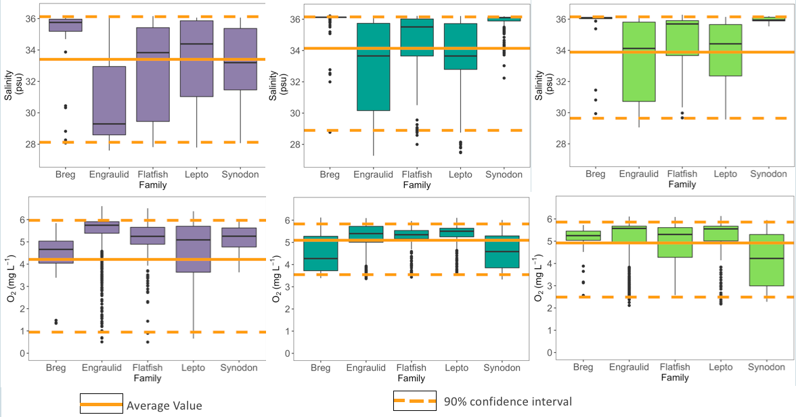

**Figure 9**. Familial affinities across all corridors with regards to salinity (psu) and dissolved oxygen (mgL^-1). The average value across all families from all pooled corridors is displayed as a solid orange line and the 90% confidence interval is displayed as a dashed orange line.

Five of the most abundant families; Engraulidae (Anchovy) , Bregmacerotidae (Codlet) , Leptocephalus (Eel) , Pleuronectiformes (Flatfish order), and Synodontidae (Lizard Fish) were chosen to be used in visualization plots. These families were all abundant in the comparable corridors (WCORR, MCORR, and ECORR) and all tended to aggregate in different regions of the water column (figure 8). Additionally these five families of fish were the most numerous across all of the transect, allowing comparative conclusions to be drawn. All corridorshave some degree of freshwater influence (lower salinity patches in the surface waters) (Figures 7,8). Engraulidae have a clear affinity for surface water (0m to 5m of every corridor) where there is low salinity and high dissolved oxygen. (Fig. 7,9) Engraulidae tend to gather at surface fronts (a boundary between distinct water masses). (Fig. 7) All other familiesreside in deeper, more saline water which originated from an offshore source. Each family tends to congregate around distinct areas of the water column. (Fig. 8,9) Leptocephalus aggregate around the thermocline and salinity gradient and tend to prefer the near shore environment. Flatfish aggregate in deeper water. Similarly, Synodontidae also aggregate in deeper water characterized by high salinity and lower than average dissolved oxygen. Bregmacerotidae aggregate in high salinity, and lower than average dissolved oxygen water as well. (Figure 9) The average dissolved oxygen of every family is above 4 mgL-1 O2 meaning fish families in every corridor show a tendency to avoid hypoxic water.

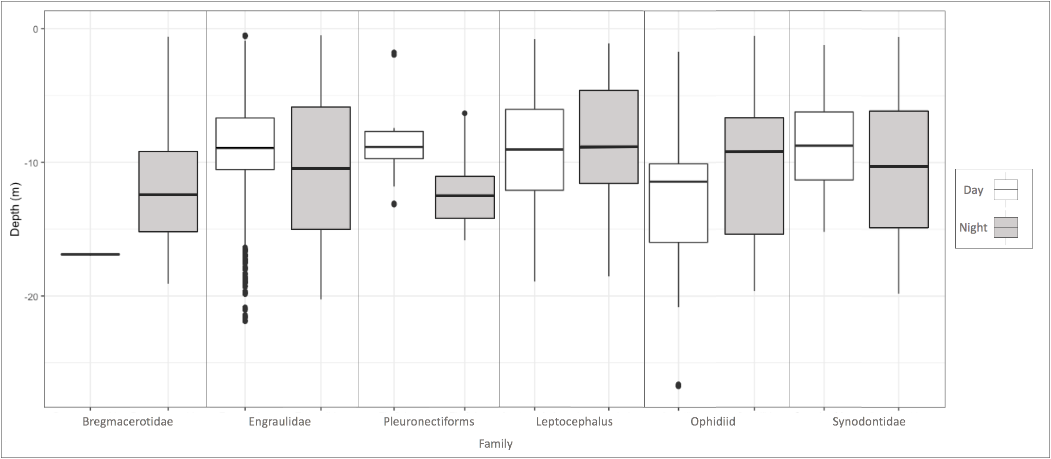

**Figure 10**. Aggregations of 6 families (Bregmacerotidae, Engraulidae, Pleuronectiformes (order), Leptocephalus, and Ophidiidae). Families from the DAY and NIGHT transects are binned together and plotted against depth in standard boxplot fashion. The center line is the average depth of the family and the edges of the box plots are 1st and 3rd quartile. Points represent outliers.

**4.4 DAY and NIGHT Corridors**

The DAY and NIGHT corridors consisted of three transects each which were samples in close temporal proximity to each other. The NIGHT corridor was conducted on July 28 2016 and the DAY corridor was conducted on July 29, 2016. The total fish in the DAY corridor (three transects combined) was 492 and 892 in the NIGHT corridor. Data from these transects have been analyzed less thoroughly than the WCORR, MCORR and ECORR data due to time constraints on the project, however findings will continue to be analyzed in the future. Preliminary findings suggest that there are strong engraulidae aggregations in the DAY corridor. (Figure 10) All three of the transects exhibit strong engraulidae aggregations around the salinity gradient. (Figure 10) The NIGHT transects exhibit significantly less aggregations and Engraulid populations are spread more randomly throughout the water column. The DAY engraulidae exhibit bottom water avoidance, especially in hypoxic water. There is no avoidance of bottom waters in the NIGHT transects, despite dissolved oxygen water levels reaching nearly 0 mgL-1 O2. Synodontidae exhibit similar behavior as the Engraulidae family. Synodontidae are closely aggregated in the DAY and more evenly spread throughout the water column during NIGHT. Bregmacerotidae, Leptocephalus and Ophidiidae exhibit diel vertical migration (lower in the water column during the day and higher at night), though it should be noted that no statistical analysis has been conducted on the data in Figure 10 and Bregmacerotidae contain only one individual for the DAY transect. Pleuronectiformes, Synodontidae and Engraulidae exhibited vertical migration in the opposite direction (higher in the water column during the day and lower at night).

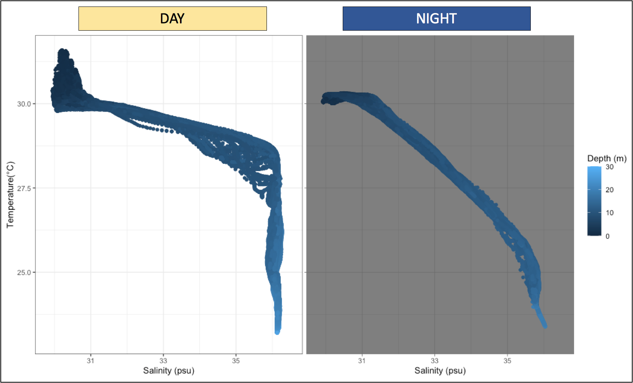

**Figure 11**. TS plots for the DAY and NIGHT corridors. Temperature (°C) is displayed on the y axis and Salinity (psu) is displayed on the x axis. Engraulidae larval fish data as a function of depth (0-30 meters) are displayed as a gradient.

The temperature verses salinity plot depicts the physical structure of the water column in both the DAY and NIGHT transects. The triplicate transects were binned and plotted together for analysis. The DAY transects exhibit a strong thermocline and halocline at 27.5 °C and 36 psu. Warmer temperatures in the day contribute to the more pronounced difference in bottom water and the warmer water on the surface. During the NIGHT transects the gradient is much more gradual indicating a less severe thermocline and halocline as the ambient atmospheric temperature drops during the night.

**5 Discussion:**

**5.1 How does Hypoxia affect larval fish distribution:**

Hypoxia is defined in this paper as dissolved oxygen concentration under 2.0 mgL-1 O2. By this definition, the WCORR had the most vertical area influenced by hypoxia, however all corridors had some levels of hypoxia. The WCORR also had the most acute hypoxia. Dissolved concentrations approached 0 mgL-1 O2 in the WCORR. From figures 7-10 it is clear that all fish families have a strong propensity to avoid hypoxic and anoxic areas. As discussed in the introduction these “dead zones” appear to be devoid of larval fish, but are no doubt filled with a vibrant microorganismal community.

The bottom water avoidance by families seen in figure 7, 8 and 9 depict constricted vertical habitat. Larval fish are residing in the top 10 meters of the water column in great quantities (upwards up 16 individuals per cubic meter). Despite the constricted vertical habitat, the WCORR contains the highest number of larval fish of all the corridors. The conditions above the thermocline are extremely favorable for larval fish of every family, especially for the Engraulidae family. The conditions beneath the thermocline are entirely avoided, even by families that are affiliated with deeper water in the MCORR and ECORR (Figure 7,8,9). The hypoxia is most severe in the summer months due to surface warming and is most acute in the WCORR and less severe or non-existent in the transects to the east. The WCORR, DAY, and NIGHT transects were all heavily influenced by Mobile bay and other localized river systems, whereas the MCORR and ECORR were progressively less influenced by riverine influence. The various corridor conditions could in the future serve as a basis for a model where the eastern corridor acts as the environmental control group, the middle corridor as a midpoint, and the western corridor as a maximum value of riverine influence and potential hypoxia hazard.

**5.2 Diel Vertical Migration in the Gulf**

Some families of larval fish in the nGOM exhibited signs of vertical migration. The average depth of Bregmacterotidae, Leptocephalus and Ophidiidae individuals during the DAY was greater than the average depth of these families at NIGHT. (Figure 10) It should be noted that the Bregmacterotidae family had one individual in the DAY transect. This behavior is possibly a tradeoff between feeding and predator avoidance. During the daylight hours, individuals of this species are low in the water column to avoid visual predators that are active. During the night they migrate vertically in the water column presumably to feed during times of lower predation threat.

The Pleuronectiformes order, Engraulidae family, and Synodontidae family exhibited unexpected vertical migration behavior. Pleuronectiformes aggregated higher in the water column during the day and lower in the water column at night, reverse of the vertical migration behavior that was expected. It is possible that Pleuronectiformes are less subject to predation from visual predation since larvae are nearly transparent (Figure 5). Synodontidae and Engraulidae were very closely aggregated around the thermocline during the DAY and much more dispersed in the water column during the NIGHT (Figure 10). This aggregation during the daylight hours may also be a predator avoidance strategy. Forage fish like the Engraulidae family often aggregate closely together in bait balls in order to protect themselves against predators if threatened. The bait ball is a concentrated mass of forage fish that can confuse predators or make it difficult for predators to find individual fish to prey upon in the vast expanses of water. Engraulidae and Synodontidae have similar body forms (Figure 5) and may be performing a similar predator avoidance technique.

**5.3 Observing Fine Scale Oceanographic Features**

The use of the ISIIS system allowed researchers to observe larval fish on a fine scale rarely seen before in research. These fine scale observations revealed several interesting points of interest in the data presented above. Two physical anomalies were found in the data, one in the WCORR and one in the MCORR.

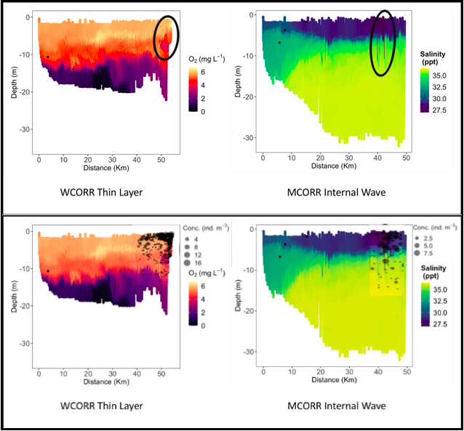

**Figure 13**: Figure indicating a low oxygen region in the Western Corridor where larval fish aggregated in large numbers and an internal wave the ISIIS detected in the MCORR. Top image depicts just the oceanographic feature, while the bottom image depicts Engraulidae aggregation concentrations at the location.

The first of these physical anomalies was found in the Western Corridor where a region of low oxygen was found higher in the water column than the traditional bottom water hypoxia common in the gulf. Formation of thin layers is unpredictable and difficult to determine since they occur at a small scale and are not very common. Buoyancy forcing (Franks 1992) coalescing of passive phytoplankton due to nearby internal waves (Frank 1992) and wind shear have all been hypothesized as the cause of these thin layers. This thin layer found in the WCORR aggregates a large amount of fish especially in the family engraulidae (Figure 13). Phytoplankton are passively coalesced in this region and as such, other trophic levels such as copepods and forage fish aggregate. This fine scale aggregation results in a high level of biological respiration, thereby drawing down the dissolved oxygen in the region. Additionally microbial communities bloom when the phytoplankton inevitably start to perish, thereby further drawing down the dissolved oxygen, as is seen in the highlighted region of figure 13.

The second fine scale physical anomaly highlighted in figure 13 is the presence of an internal wave. The salinity and temperature data from this region illustrate spikes or intrusions of low salinity and high temperature into a water mass with higher salinity and lower temperatures. It is hypothesized that this fine scale feature is an internal wave mixing the water masses across the local thermocline and halocline. Figure 13 indicates that the region is aggregating fish, though not as strongly as the thin layer present in the WCORR. Since the data in both of these corridors represents a snapshot of time, it is impossible to determine if a thin layer may have formed at this internal wave in the coming hours or days, but it is an interesting physical feature none the less. Continued use of fine scale ROTVs such as the ISIIS will allow scientists to better understand physical anomalies such as internal waves, thin layers, and fronts that tend to coalesce phytoplankton and aggregate larval forage fish.

**5.5 Conclusions**

Copious questions remain surrounding forage fish in the Gulf of Mexico. It is still unclear why the Engraulids aggregate at surface fronts, internal waves, and thin layers. Using the full set of ISIIS camera data could help answer if the front is coalescing prey for the Engraulids. Comparing copepods (and other zooplankton data) between the front and other surface water regions could lead to conclusions about this phenomenon. Phytoplankton are often passively coalesced by fronts but post but it is unclear how much these fronts and the severity of the currents in the fronts contribute to aggregation. Are the fish aggregated by the physics of the front itself or does the presence of copious amounts of prey attract and allow the fish that find the front to survive. Additionally ImageJ could be used to further investigate the affinity for certain body positions in different families of fish.

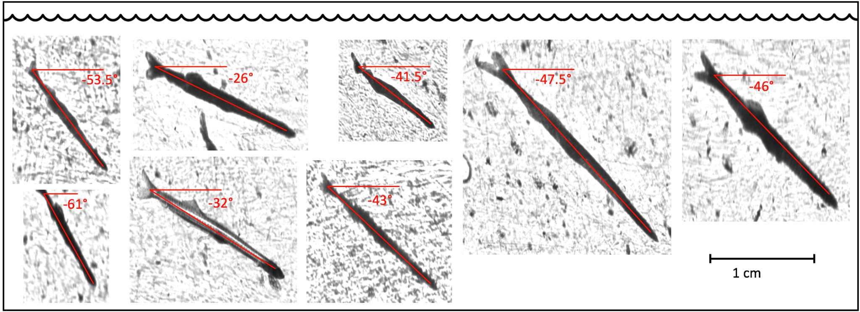**Figure 14.** Selected members of the family Engraulidae from the DAY corridor. Many individuals across all of the corridor from the Engraulidae family (post-flexion) exhibited similar orientation in the ISIIS data. The orientations of these individuals in figure 4 range from -26° to -61°with the average being -43.8°.

A distinct pattern of orientation was discovered in some of the larval fish images. Figure 6 displays members of the Engraulidae family all in similar orientation with regards to the ISIIS ROTV. The affinity for this orientation was seen in every corridor, specifically in the Engraulidae family, though was also commonly seen in the Gobiidae, “Thin and Pointy” and Wrasse families as well. This orientation was most common in larger larval fish that were post-flexion. During the post-flexion stage larval fish develop caudal fins, pigmentation, and scales. This stage marks the full development and final positioning of fins in the larval fish life cycle. It is hypothesized that since these larval fish are in the later stages of development, they may be able to more effectively avoid potential predators or disturbances, which in this case would be the ISIIS glider. The affinity for approximately -43.8° may suggest the fish is attempting to flee away and lower into the water column as it is being photographed. Smaller pre-flexion fish would most likely be unable to flee the ISIIS in an effective manner due to their ineptitude for swimming. Unfortunately smaller pre-flexion fish are often not segmented in the first stage of image analysis due to their small size. It is assumed that nearly 50% of larval fish that are present in the corridors are missed due to their small size and the 2000 pixel (3.0 mm esd).

Lastly, the DAY and NIGHT corridors could be statistically analyzed to determine if the vertical migration seen is significant. Due to time constraints on the project, these questions for now are unanswered. With more time and further statistical analysis these ideas and questions would surely be answered with the robust data set described in the paper.

**References:**

P. J., & Franks. (1995). *Thin layers of phytoplankton: a model of formation by near-inertial wave shear*. Elsevier BV. 10.1016/0967-0637(94)00028-q

Alder, J., Campbell, B., Karpouzi, V., Kaschner, K., & Pauly, D. (2008). Forage Fish: From Ecosystems to Markets. *Annual Review of Environment and Resources, 33*(1), 153-166. 10.1146/annurev.environ.33.020807.143204

Allen, D., & Barker, D. (1990a). Interannual variations in larval fish recruitment to estuarine epibenthic habitats. *Marine Ecology. Progress Series (Halstenbek), 63*(2/3), 113-125. 10.3354/meps063113

Allen, D., & Barker, D. (1990b). Interannual variations in larval fish recruitment to estuarine epibenthic habitats. *Marine Ecology. Progress Series (Halstenbek), 63*(2/3), 113-125. 10.3354/meps063113

Axler, K., Sponaugle, S., Briseño-Avena, C., Hernandez, F., Warner, S., Dzwonkowski, B., Dykstra, S., & Cowen, R. (2020). Fine-scale larval fish distributions and predator-prey dynamics in a coastal river-dominated ecosystem. *Marine Ecology. Progress Series (Halstenbek), 650*, 37-61. 10.3354/meps13397

Burke, W. D. (1999). Gordon Pennington Gunter, 1909-1998. *Gulf Research Reports, 11*, 65. 10.18785/grr.1101.09

*CAMPANA, S. E. (2005). Otolith science entering the 21st century. Marine and Freshwater Research, 56(5), 485-495. 10.1071/MF04147*

Cowen, R. K., & Guigand, C. M. (2008). In situ ichthyoplankton imaging system (ISIIS): system design and preliminary results. *Limnology and Oceanography, Methods, 6*(2), 126-132. 10.4319/lom.2008.6.126

Ditty *et al 1988 - northern gulf of mexico fish larvae distribution*

Dzwonkowski, B., Park, K., & Collini, R. (2015). The coupled estuarine-shelf response of a river-dominated system during the transition from low to high discharge. *Journal of Geophysical Research. Oceans, 120*(9), 6145-6163. 10.1002/2015JC010714

Greer, A. T., Personal Communication (2019-2022)

Greer, A. T., Boyette, A. D., Cruz, V. J., Cambazoglu, M. K., Dzwonkowski, B., Chiaverano, L. M., Dykstra, S. L., Briseño‐Avena, C., Cowen, R. K., & Wiggert, J. D. (2020). Contrasting fine‐scale distributional patterns of zooplankton driven by the formation of a diatom‐dominated thin layer. *Limnology and Oceanography, 65*(9), 2236-2258. 10.1002/lno.11450

GREER, A. T., COWEN, R. K., GUIGAND, C. M., MCMANUS, M. A., SEVADJIAN, J. C., & TIMMERMAN, A. H. V. (2013). Relationships between phytoplankton thin layers and the fine-scale vertical distributions of two trophic levels of zooplankton. *Journal of Plankton Research, 35*(5), 939-956. 10.1093/plankt/fbt056

Greer, A. T., Cowen, R. K., Guigand, C. M., & Hare, J. A. (2015). Fine-scale planktonic habitat partitioning at a shelf-slope front revealed by a high-resolution imaging system. *Journal of Marine Systems, 142*, 111-125. 10.1016/j.jmarsys.2014.10.008

Greer, A. T., Lehrter, J. C., Binder, B. M., Nayak, A. R., Barua, R., Rice, A. E., Cohen, J. H., McFarland, M. N., Hagemeyer, A., Stockley, N. D., Boswell, K. M., Shulman, I., deRada, S., & Penta, B. (2020). High-Resolution Sampling of a Broad Marine Life Size Spectrum Reveals Differing Size- and Composition-Based Associations With Physical Oceanographic Structure. *Frontiers in Marine Science, 7*10.3389/fmars.2020.542701

Greer, A., Shiller, A., Hofmann, E., Wiggert, J., Warner, S., Parra, S., Pan, C., Book, J., Joung, D., Dykstra, S., Krause, J., Dzwonkowski, B., Soto, I., Cambazoglu, K., Deary, A., Briseño-Avena, C., Boyette, A., Kastler, J., Sanial, V., . . . Graham, W. (2018). Functioning of Coastal River-Dominated Ecosystems and Implications for Oil Spill Response. *Oceanography (Washington, D.C.), 31*(3), 90-103. 10.5670/oceanog.2018.302

“Gulf of Mexico Hypoxia Watch.” *National Centers for Environmental Information (NCEI)*, 15 Dec. 2021, https://www.ncei.noaa.gov/products/gulf-mexico-hypoxia-watch.

H. Wickham. ggplot2: Elegant Graphics for Data Analysis. Springer-Verlag New York, 2016.

*Larval fish assemblages in a tropical mangrove estuary and adjacent coastal waters- Offshore–inshore flux of marine and estuarine species*

Letcher, B. H., & Rice, J. A. (1997). Prey patchiness and larval fish growth and survival: inferences from an individual-based model. *Ecological Modelling, 95*(1), 29-43. 10.1016/S0304-3800(96)00015-4

Muhling, B., Lamkin, J., & Richards, W. (2012). Decadal-scale responses of larval fish assemblages to multiple ecosystem processes in the northern Gulf of Mexico. *Marine Ecology. Progress Series (Halstenbek), 450*, 37-53. 10.3354/meps09540

Omin, A.*Roles of Behavioral and Physical Factors in Larval and Juvenile Fish Recruitment to Estuarine Nursery Areas*

Pfirrmann, B. W., Kimball, M. E., Mace, M. M., & Turley, B. D. (2021). Summer Ichthyoplankton Assemblage Diversity Within a Southeastern United States Estuary. *Estuaries and Coasts, 44*(1), 253-268. 10.1007/s12237-020-00777-2

Rivers, J. W., Guerrero, J. B., Brodeur, R. D., Krutzikowsky, G. K., Adrean, L. J., Heppell, S. A., Jacobson, K. C., Milligan, K., Kim, S., , N. |., Roby, D. D., Sydeman, W. J., Torres, L. G., & Barth, J. A.*Critical Research Needs for Forage Fish within Inner Shelf Marine Ecosystems*10.1002/fsh.10725

Roman, M. R., Brandt, S. B., Houde, E. D., & Pierson, J. J. (2019). Interactive Effects of Hypoxia and Temperature on Coastal Pelagic Zooplankton and Fish. *Frontiers in Marine Science, 6*10.3389/fmars.2019.00139

Schmid, M. S., Cowen, R. K., Robinson, K., Luo, J. Y., Briseño-Avena, C., & Sponaugle, S. (2020). *Prey and predator overlap at the edge of a mesoscale eddy: fine-scale, in-situ distributions to inform our understanding of oceanographic processes*. Springer Science and Business Media LLC. 10.1038/s41598-020-57879-x

​​Schneider, C., Rasband, W. & Eliceiri, K. NIH Image to ImageJ: 25 years of image analysis. *Nat Methods* 9, 671–675 (2012). https://doi.org/10.1038/nmeth.2089

Schunter, C., Pascual, M., Raventos, N., Garriga, J., Garza, J. C., Bartumeus, F., & Macpherson, E. E. (2019 ). *A novel integrative approach elucidates fine-scale dispersal patchiness in marine populations*. Springer Science and Business Media LLC. 10.1038/s41598-019-47200-w

Sloterdijk, H., Brehmer, P., Sadio, O., Müller, H., Döring, J., & Ekau, W. (2017). Composition and structure of the larval fish community related to environmental parameters in a tropical estuary impacted by climate change. *Estuarine, Coastal and Shelf Science, 197*, 10-26. 10.1016/j.ecss.2017.08.003