Oceans of Plankton:
Designing an interactive exhibit and evaluating engagement with aquarium visitors
Taylor Kilgore
Non-Thesis Master’s Project
Department of Marine Sciences
University of Georgia
May 2023

INTRODUCTION
Science communication facilitates public understanding of basic concepts in marine research as well as see the value in studying oceans. Science communication is the practice of informing, educating, and raising awareness of science-related topics (Nick, 2021) and can take place through a variety of mediums, such as blogs, seminars, videos, infographics, and workshops. Science communication and science education aim to expose the public to scientific knowledge, which is quickly becoming a requirement for effective participation in modern society (Kohen et al., 2019). Having more knowledge allows for more informed decision-making and a better understanding of the natural world (Kohen et al., 2019). In marine sciences, helping the public understand and gain enthusiasm for marine ecosystems and organisms can help them understand the importance of ocean sciences as well as recognize the types of footprints we can leave on the ocean. Communication, education, and outreach allow scientists to engage and inform the public about research currently being done in our oceans.

Communication in Exhibits
Educational exhibits are one way to communicate basic scientific concepts to a broad audience. Exhibits and attractions are constantly being re-evaluated and updated to utilize new technology advancements. New exhibits are being unveiled frequently, but the effectiveness of these displays vary (Afonso et al., 2007). Effectiveness is the amount of time spent at the exhibit or the amount of information learned, and it can be evaluated through engagement (Ross et al., 2009). Engagement is defined as one minute of attention on an object or display (Haywood et al., 2006). This may sound like an easy feat. However, gaining the attention of an individual can be difficult depending on the person’s age, education-level, or general interest in the subject. Knowing what exactly initiates engagement can be an advantageous tool to educational organizations because they can tailor their exhibits to better reach a target audience. A more effective exhibit will lead to more engagement among visitors.
The effectiveness of an exhibit can be quantified in many ways, one of which is remedial evaluation. This involves interviewing individuals and asking specific questions about the exhibit (Moss, 2019). Answers can be given via qualitative or quantitative data. Though quantitative data is useful with large sample sizes, qualitative data offers more personalized responses (Moss et. al., 2019). Quantitative data allows for analysis of general opinions of a display (rank 1-5), whereas the goal for qualitative data is to search for key terms and phrases in the responses. Individuals who were engaged as well as those who were not are valuable in learning about the effectiveness of an exhibit. Those who were engaged can answer questions such as “What caught your attention?” and “What did you learn?” whereas those who were not engaged can answer questions like “What is missing to catch your attention?” and “What would you have liked to see differently?” Both types of questions can help educational organizations see a preference for either process or product in their future exhibits as well as increase the likelihood that their exhibit will inspire pro-environmental action through making visitors contemplate what they gained from the exhibit.
Engagement and effectiveness can be influenced by the exhibit’s design, which has two categories: process and product. Distinguishing between process and product helps exhibit creators evaluate how the general appearance of an exhibit interacts with the content of an exhibit to affect engagement. Process is the actual design of the exhibit (Ashima, 2013; Stufflebeam, 2000). This includes the colors, fonts, placement of the different parts of the exhibit, etc. Product is the content of the exhibit (Ashima, 2013; Stufflebeam, 2000). This includes the pictures, context, or educational components of the exhibit. Both process and product are important to consider in the implementation of an exhibit. However, emphasis on one or another may increase engagement within certain visitor demographics (Allen, 2004). For example, a couple with children may be engaged by different elements than a couple without children. Figuring out what elements engage certain audiences is extremely helpful in designing exhibits. Knowing the audience and overall goals can allow exhibit designers to decide whether process or product components can be responsible for capturing the attention of visitors.

Exhibits within Aquariums
Aquariums provide a way to communicate science to the public, but exhibits are usually geared towards large and charismatic animals. It is estimated that more than 700 million people visit zoos and aquariums worldwide (Visitor Demographics, n.d.). The average medium-sized aquarium has about 394 different species, with most species being visible and obvious for visitors to identify and point out (Marcy, 2021). Visitors love to learn and interact with exhibits that include intelligent, large, or famous animals that have been featured in movies and television. According to Instagram, the most hash tagged marine animals include polar bears, orcas, sharks, and dolphins (Positive Travel, 2020). However, the smaller, often indiscernible animals, such as plankton, are potentially more important to the function of the ocean ecosystems because they are so abundant.
Plankton are a diverse group of organisms that are often unknown to the public. Plankton are organisms that cannot swim against ocean currents and span a wide size range from microscopic animals to larger species, such as jellyfish (NOAA, 2020). Phytoplankton perform photosynthesis, producing oxygen and supporting the basis for the ocean’s food chain. Zooplankton are comprised of small animals and the larval forms of larger animals (NOAA, 2020). Meroplankton are zooplankton who only spend a portion of their lives as plankton, whereas holoplankton are zooplankton who spend their entire lives in the plankton (NOAA, 2020). Plankton as a whole make up the majority of the ocean’s biomass and are important indicators of the ocean’s health due to their sensitivity to both long-term and short-term environmental changes. However, some of them are fragile and hard to sample, so people are generally unaware of them and the vital role they plan in our oceans.

Technology in Outreach
A new, permanent exhibit featuring life cycles in the ocean was designed and implemented into the UGA Marine Education Center and Aquarium in Savannah, GA. This exhibit encompassed one of the main outreach components from NSF Grant #2023133. The Zooplankton Ecological Responses to Oceanic Conditions (ZERO-C) lab received this grant for their Dol-MICROBE project, which studies how the presence or absence of doliolids, which are a gelatinous holoplankton, influences microbial processes and the South Atlantic Bight food web (Greer et al., 2023). Since plankton are small, and some are fragile, they can often be difficult to observe and quantify in their natural environment. Cameras are particularly effective for studying gelatinous forms of plankton that are often destroyed or damaged in towed plankton nets (Benfield et al., 2007). Shadowgraph imaging is an optical technique that uses a gray scale camera and collimated light to produce shadow images (Lombard et al., 2019). A light pod and camera pod are set apart from each other. A blue light shines as the water passes through, which creates shadow images of the organisms between the pods (Greer et al., submitted). These camera setups can be placed on towed systems (along with other oceanographic sensors) that researchers can use to study plankton in a way that is non-invasive and non-damaging to the organisms (Benfield et al., 2007). The towed camera systems also generate large image data sets of plankton within the water column, where each individual has a specific known depth and associated oceanographic characteristics (e.g., salinity, temperature, dissolved oxygen). These images are then processed and annotated using software, manual annotation, and artificial intelligence (Lombard et al., 2019). Understanding how plankton are studied can help the public visiting the MAREX Aquarium understand the fragility of the plankton, and how these towed camera systems are helping researchers understand the ecological role of plankton populations through non-invasive sampling.
Through this project, and similar research in other oceans, the ZERO-C lab has collected hundreds of thousands of images of planktonic organisms, which create a unique outreach opportunity. The data from these camera systems can help researchers better understand plankton population dynamics, but they also give insight into the diverse world of the plankton community. Plankton are usually indiscernible to the naked eye, causing many within the public to be unaware of the community and its importance to marine ecosystems and fishing industries. This exhibit hopes to remedy that through sharing the images created from the shadowgraph data sets. Educating the public about life cycles within the ocean and the importance of the plankton community can help bring awareness to the ways humans impact our oceans through pollution and advocate for more sustainable practices within society.
My project explores how shadowgraph images can be used in educational exhibits and how certain exhibit elements can increase engagement among aquarium visitors. Along with MAREX representatives, I assisted in the development of a learning objective and the design of various exhibit features that highlight shadowgraph imaging and plankton technology. From there, I surveyed aquarium visitors to see which parts of the exhibit were the most successful in increasing engagement. Creating this exhibit and completing this survey showed how shadowgraph images can be used within educational exhibits as well as how certain exhibit features can increase engagement among different age groups.

METHODS
Exhibit Planning
I worked with Dr. Adam Greer and various educators and public relations employees within the MAREX Aquarium to develop an exhibit that highlights the plankton community and their role in marine life cycles. Utilizing the backward design approach (Bowen, 2017), we began by developing learning objectives that best fit our overall goals for the exhibit. We wanted to help citizens of all ages understand that most ocean animals spend part, if not all, of their lives as plankton. From there, we were able to decide on the various aspects of the exhibit. We wanted to highlight the technology used to sample the plankton, their role in oceanic life cycles, why people should care, and what they could do to help preserve plankton habitats. After meeting several times, we decided on three major parts for the exhibit: a poster, video, and life cycle diagrams. The poster gives general information about plankton and explains how humans can impact their environment. The video uses the poster as a companion to explain how plankton are sampled in the ocean. It succinctly documents the shadowgraph’s deployment, retrieval, and data analysis. We designed tactile wheels that spin to reveal different parts of an organism’s life cycle, showing how their planktonic form is often vastly different from their adult morphology. We also created a to-scale rendition of the summer flounder’s life cycle to give visitors an idea of the dramatic size changes that many ocean animals undergo throughout their life cycle.

Poster Development
The poster was broken into four sections: an overview, Picturing Plankton, Life Cycles of the Sea, and Completing the Cycle. The overview section introduced the types of plankton (zooplankton vs. phytoplankton) and some of their roles in the ocean such as their function within food webs, nutrient cycling, and oxygen production. The “Life Cycles of the Sea” section explained zooplankton, discussing their development from eggs to larval forms and beyond. It highlighted their importance in the seafood and shellfish industries as well as how their population dynamics can give insight to the overall health of the oceans. The “Picturing Plankton” section was a companion to the video that was developed and explained the technology used to study plankton. It included a diagram of the various parts of the shadowgraph as well as some images taken using the towed camera system. The final section is “Completing the Cycle,” which included the “call to action” piece. This paragraph explained how our actions along the coast can affect plankton habitats through pollution and chemical dumping. It encouraged visitors to practice the safe disposal of household chemicals and waste while also avoiding the use of pesticides and herbicides on lawns.
Assisting in the development of these different sections allowed me to assess and decide what information is the most relevant and important for visitors to know. Plankton and marine life cycles can be complicated, but we worked to communicate their importance and significance within ocean ecosystems in a way that is interesting and clear to visitors. Since 54% of American adults read below a sixth-grade level (Literary Statistics, 2022), avoiding jargon and technical terminology was a focus for this exhibit. Overall, assisting in the development of the poster helped me weigh and determine the best strategies for communicating a difficult topic.

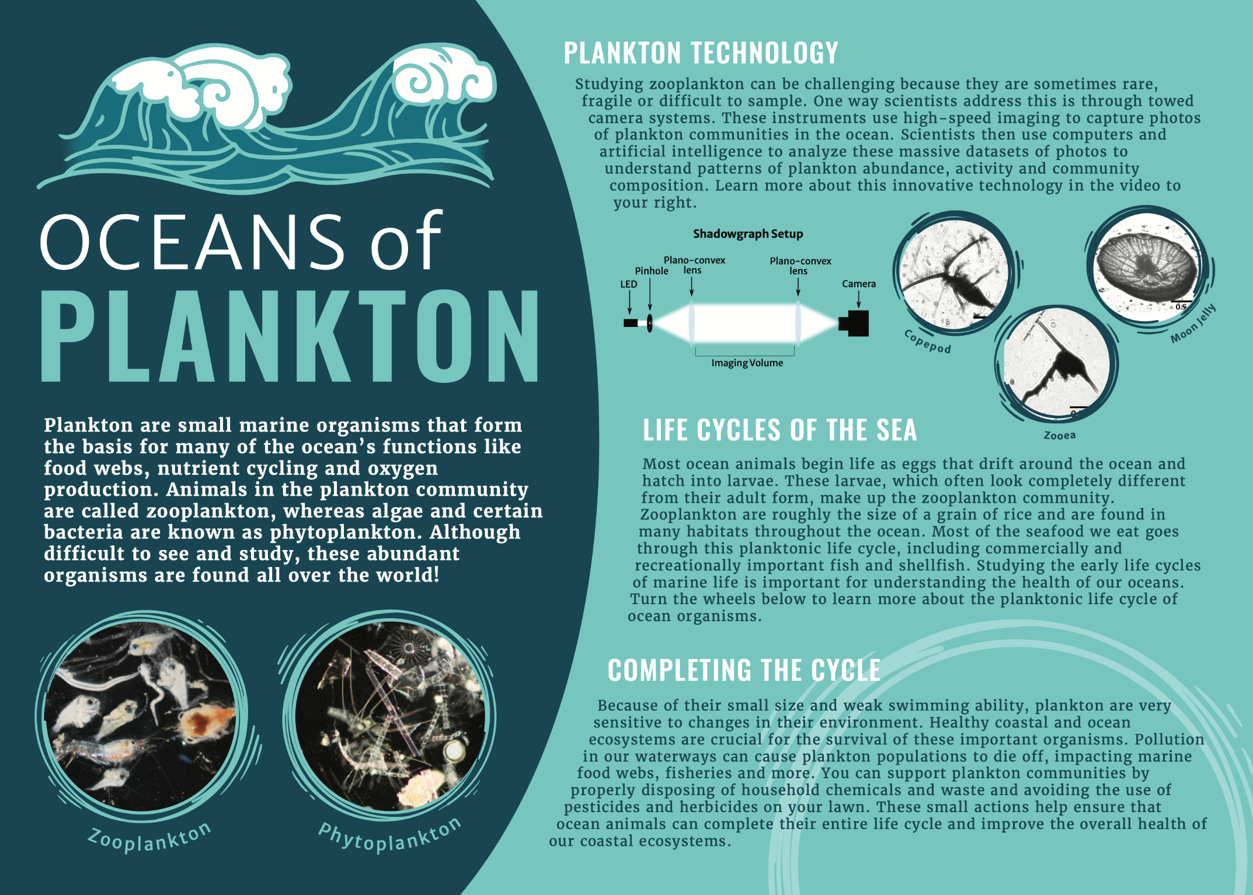
Figure 1: A mock-up of the poster on display at the UGA MAREX Aquarium.
Picturing Plankton
To better understand the shadowgraph imaging technology, I worked with members of the ZERO-C lab to assist in identifying tunicates from the images taken. I assisted in sorting and identifying over 150,000 images, mostly of gelatinous animals such as salps and doliolids. I also looked through the data sets to find clear images that could be used in the exhibit’s poster. Some images are blurry since the organisms can be moving at the time of the camera’s capture, so I worked to find images that were clear and of more well-known animals (e.g., larval crabs, lobsters, and fishes). I added scale bars to these images to give an idea of their size to the illustrator and poster designer who was able to adjust them appropriately.
Assisting in image analysis allowed me to gain a deeper understanding of the shadowgraph imaging technology so that I could create the video that explains and documents the process of the towed camera system. Students from the Savannah College of Art and Design (SCAD) had previously video-documented a research cruise with the ZERO-C lab. During this trip, the SCAD student took video footage of the scientists deploying and recovering the imaging system, as well as viewing the live feed of the data on the ship. Together, this collection of video clips provided a full account of the sampling process – from data collection to analysis. However, the clips were disorganized and unannotated. I combed through hours of footage and identified the most relevant clips to understand how the technology works and what scientists do onboard a research vessel. In addition, a GoPro had been attached to the towed camera system pointing towards the rear of the vehicle, giving a unique view to the underwater world and wildlife. Many charismatic animals tend to follow the camera system around possibly because it provides structure, or the animals are just curious. The footage was compiled into a short video with subtitles that highlighted the shadowgraph camera system’s features and deployment. We decided to use subtitles to document the video instead of sound to prevent distraction from other parts of the aquarium. The video gave viewers an idea of how the towed camera system works as well as included some fun aspects such as dancing dolphins behind the camera and live plankton videos. It also gave insight to some of the careers within the marine sciences through documenting one of the various ways to study biological oceanography. Creating this video helped me better understand the plankton technology as well as serve as a fun experience in learning how to communicate science through videography.

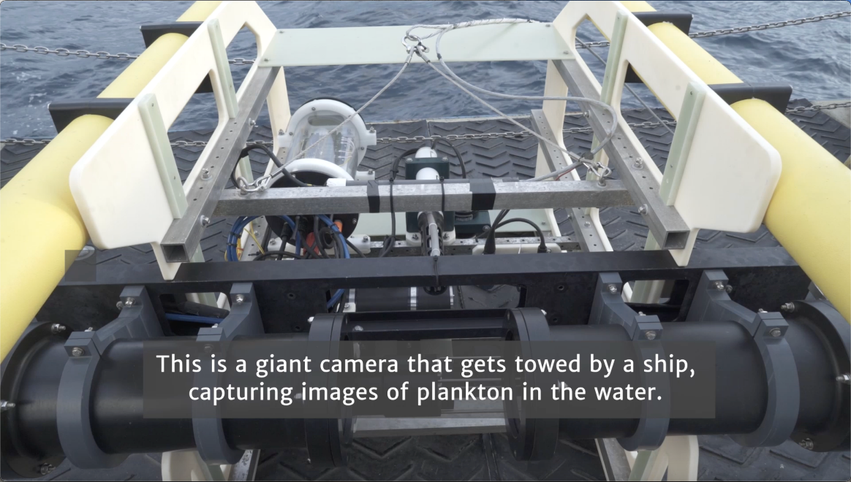
Figure 2a: The shadowgraph camera.
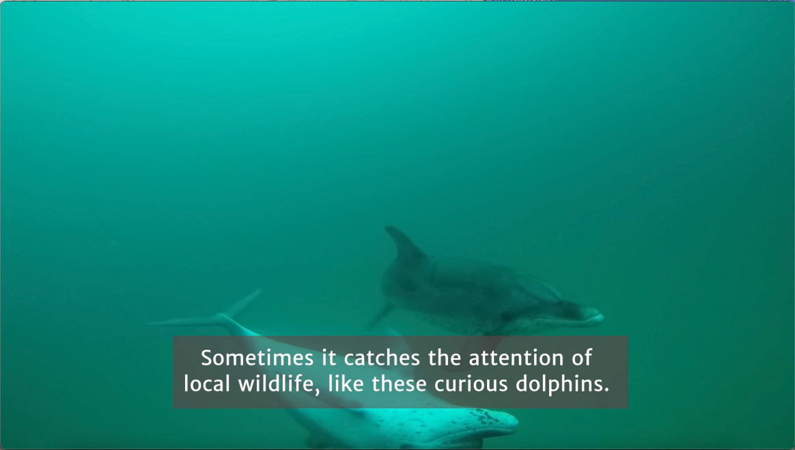
Figure 2b: Dolphin footage caught by the GoPro camera.
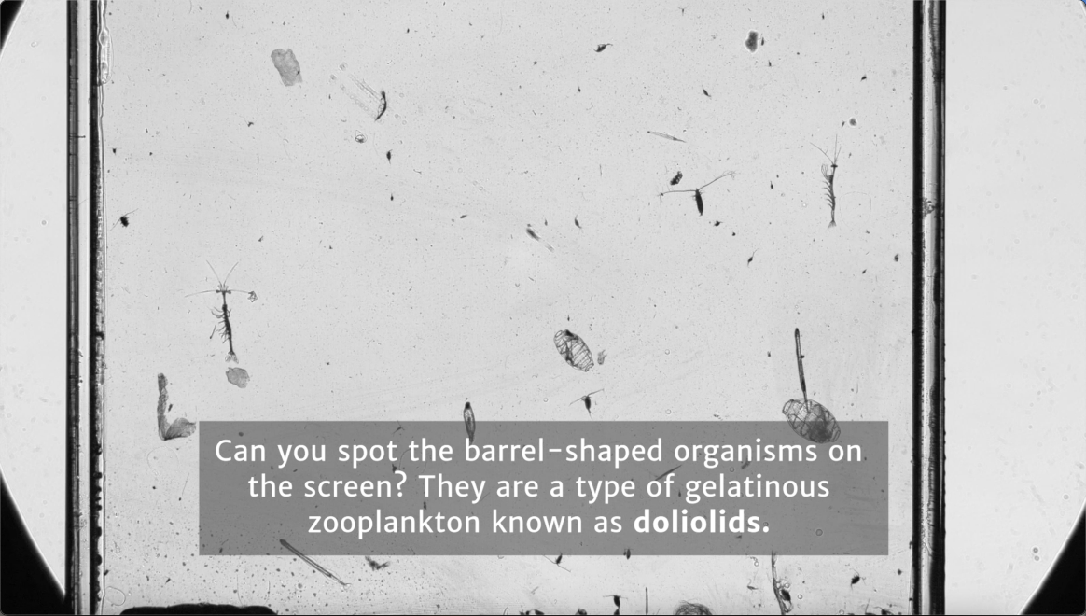
Figure 2c: An example of the type of footage caught by the shadowgraph.

Life Cycle Wheel Diagrams
The final major aspect of this exhibit was the life cycle diagrams. Many people do not realize that the larval forms of organisms often look extremely different from the adult forms. The tactile wheels and to-scale summer flounder hoped to alleviate some of that misunderstanding through showing the various stages of an organism’s life cycle and the size changes during its life history.
We wanted a fun, interactive aspect in the exhibit – something that would appeal to children and those who learn kinesthetically. Interactive elements can also increase visitor interest and user experience (Panagiotis et al., 2013). We worked with Keith Kratz, a local scientific illustrator, to choose the most interesting phases of life cycles for three coastal Georgia species: doliolid, blue crab, and grouper. We chose these organisms because each have a different role in the plankton community. Doliolids spend their entire lives as plankton, whereas blue crabs and grouper go through various morphological changes before leaving the plankton community and becoming free swimming or semi-sedentary juveniles and adults. I worked to put together the various parts of their life cycle, finding images and drawings to show the different stages. We decided against scale bars for simplicity in the design. The illustrator was then able to take this information and create a life cycle diagram for each species. On the exhibit, they are each covered with an opaque board with a pie section cut out. Screws allow the opaque portions to spin around and reveal a singular part of the life cycle. These spinning wheels allowed the visitor to interact with the exhibit and see a different life stage of a familiar marine animal. Our goal was that visitors would spend more time engaging with the exhibit by spinning the wheels to reveal the life cycles of species found within Georgia’s coasts.
To give visitors an idea of how an organism may grow throughout its lifetime, a to-scale drawing of the summer flounder was placed besides the poster and tactile wheels. This diagram gave viewers an idea of the various size changes an organism may go through during its life cycle. We wanted visitors to see that the summer flounder, which can grow up to three feet long, begins life as a tiny, nearly microscopic egg (NOAA, 2022). The diagram also showed how the larval form of an organism can look completely different compared to its adult morphology. Developing these various life cycle diagrams allowed me to explore ways to communicate science through different learning strategies. From an environmental action standpoint, this level of life-cycle knowledge was important for the public to know because it helped them visualize the size of plankton and their resulting sensitivity to their environment.

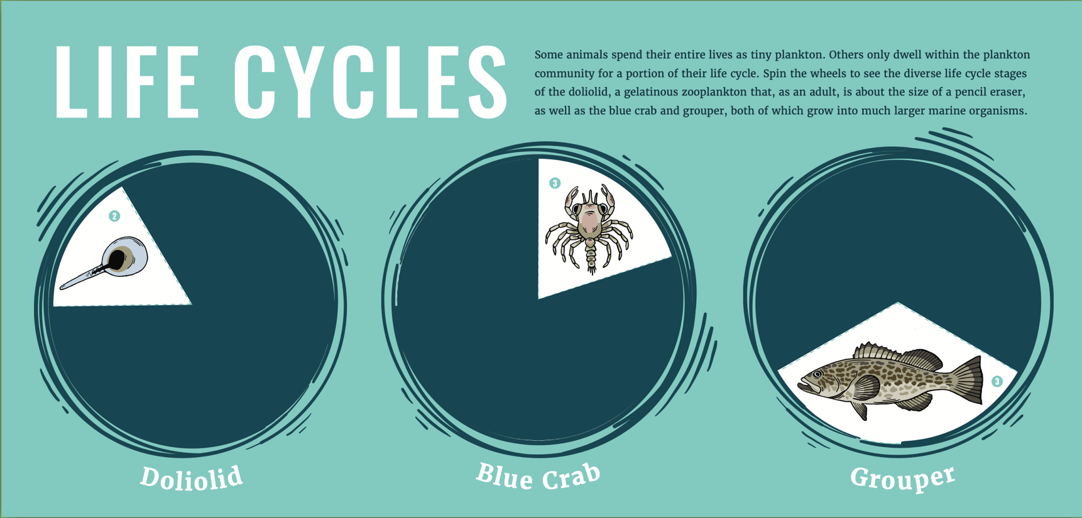
Figure 3a: A mock-up of the spinning wheels on display at the UGA MAREX Aquarium.
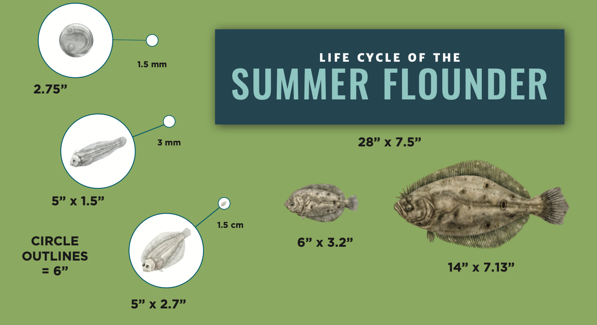
Figure 3b: A mock-up of the summer flounder life cycle on display at the UGA MAREX Aquarium.
Figure 3c: The doliolid life cycle.
Figure 3d: The blue crab life cycle.
Figure 3e: The grouper life cycle.
Oceans of Plankton Survey
Identifying the features within an exhibit that help visitors understand important concepts can aid in improving future exhibit designs. To assess the new Oceans of Plankton exhibit, a survey was conducted to find whether process or product was responsible for increasing engagement. The process for this exhibit included three different components: a poster, video, and spinning wheels. The poster and video are visual components, whereas the spinning wheels are tactile components. Aesthetically pleasing colors were used to complement the surrounding area of the aquarium, and fonts that are easily read were used for clear understanding and reading. The product of this exhibit included the poster with both black and white shadowgraph images of plankton and color images. There are four different sections for the poster: Oceans of Plankton Introduction, Life Cycles of the Sea, Picturing Plankton, and Completing the Cycle. The content of the video shows the deployment, underwater footage, and retrieval of the instruments used to study the plankton. The spinning wheels included the life cycles of three different organisms – a blue crab, grouper, and doliolid. Visitors were able to spin a wheel to reveal different portions of their life cycle. Distinguishing between these features and their process/product components revealed which elements of the exhibit were responsible for initiating and increasing engagement among visitors of the MAREX Aquarium.

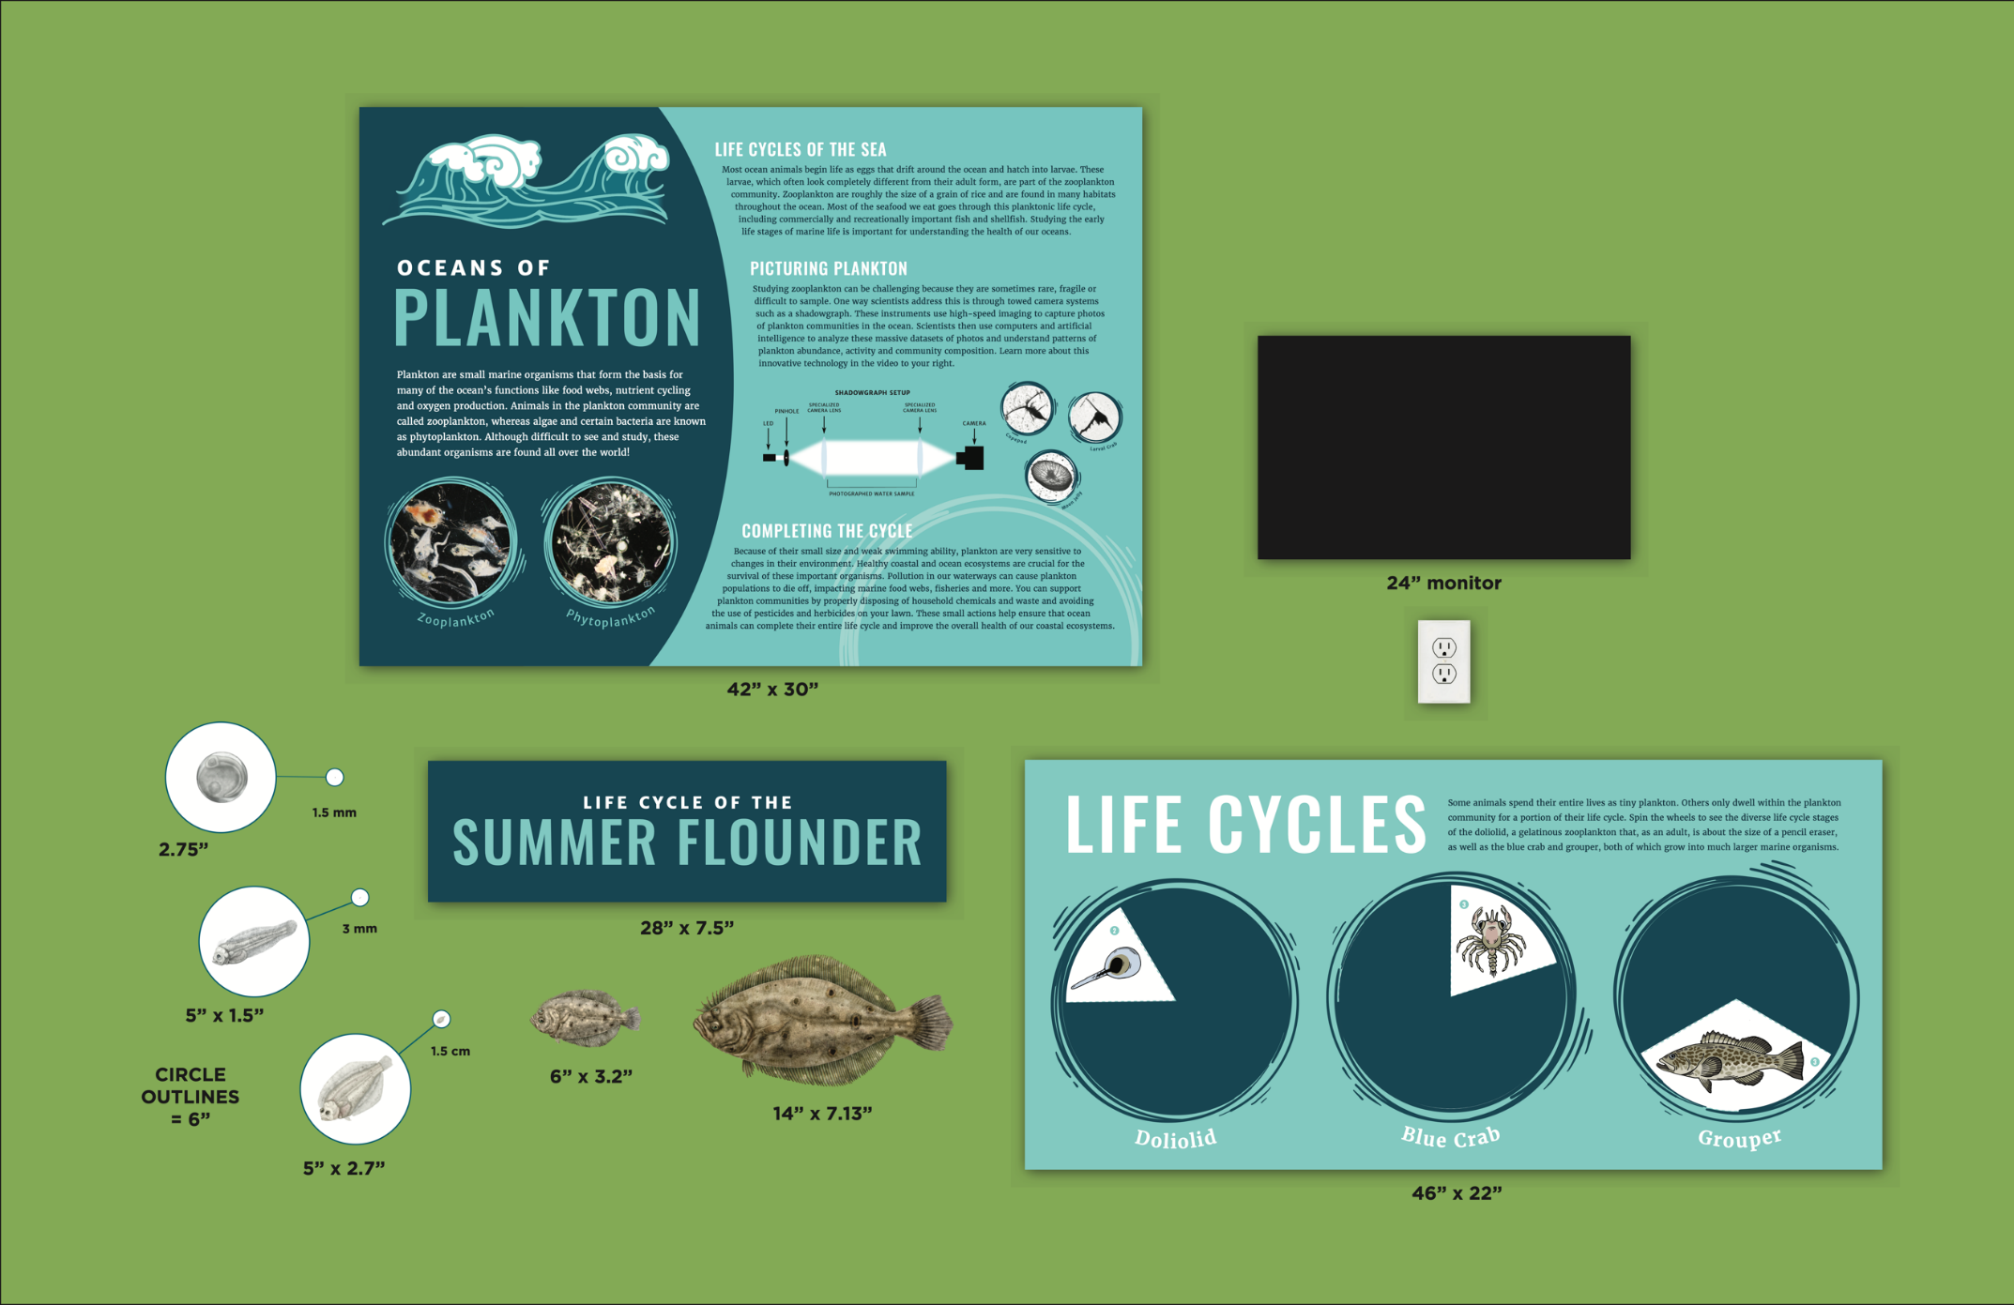
Figure 4: A mock-up of the complete exhibit on display at the UGA MAREX Aquarium.

Data Collection
Paper surveys were distributed among 100 visitors as a form of remedial evaluation. The survey was a combination of both ranking (quantitative data) and fill-in-the-blank questions (qualitative data). The questions pertained to either the process or product aspect of the exhibit. Visitors were encouraged to view and spend time with the exhibit before filling out their questionnaire. Once responses were recorded, they were transferred into Google Forms and converted into an excel file. The data were sorted by age group (child, teen, or adult), and percentages were used in analysis since there was an unequal amount of people within each group. The amount of time spent at the exhibit, the type of interaction used by the visitor, and the average responses for the qualitative questions were graphed to compare the different age groups.
The qualitative responses were separated into “process” or “product” depending on their answer. Process terms include “colors, fonts, lighting” as well as the general parts of the display such as “poster, video, wheels.” Product responses include keywords such as “technology, plankton, life cycle” that address the content of the exhibit. The responses for the qualitative questions, “What initially caught your attention?” and “What was the best part of this exhibit?” were also analyzed for references to the poster, video, wheels, or other parts. This analysis was done regardless of the “process” or “product” distinction to look at which components were the most successful in catching and holding people’s attention. There was also a classification for answers that did not directly correlate to the three main parts of the exhibit. These responses were designated as “Other” and were compared to the poster, video, and life cycles. Data visualizations were generated in R using the package “ggplot2” (Wickham, 2016).

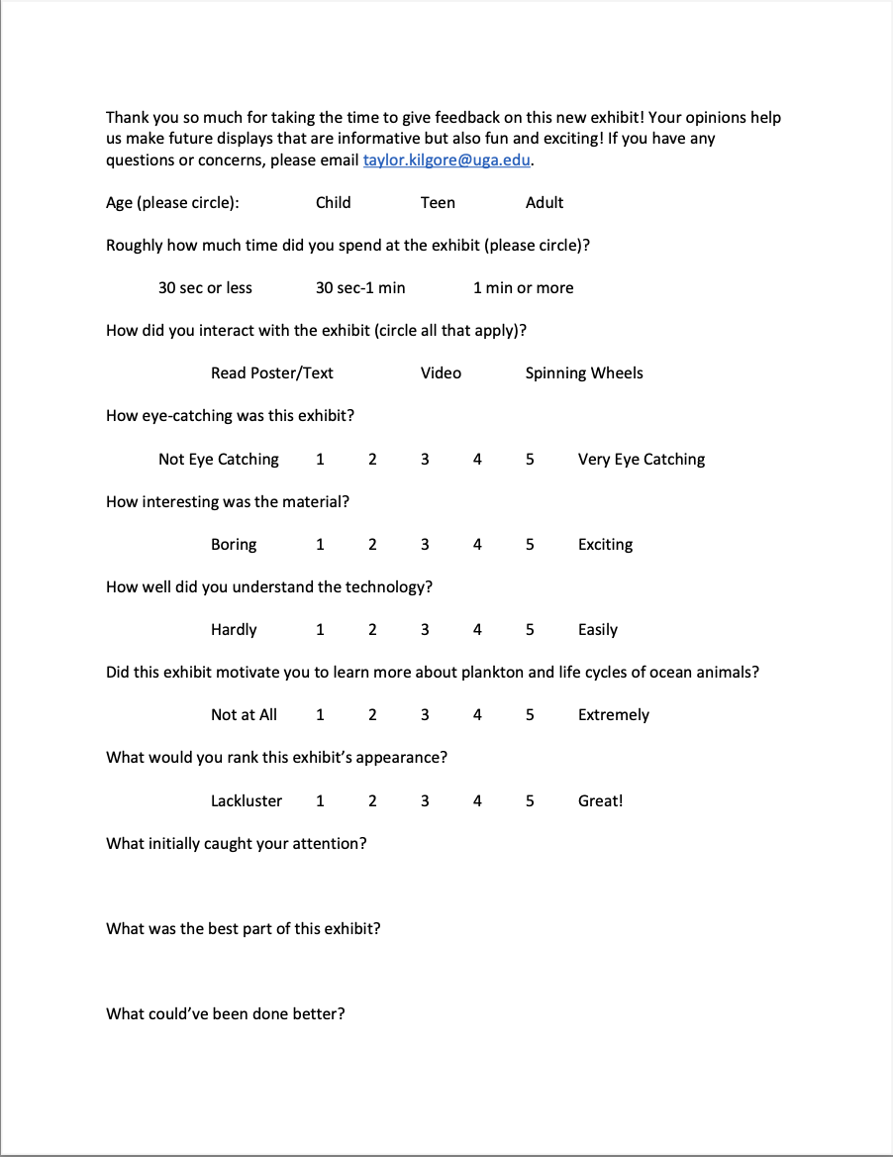
Figure 5: The questionnaire shared with aquarium visitors to evaluate the Oceans of Plankton exhibit.
Survey Predictions
The goal of the survey was to assess whether process or product initiates and holds engagement in a scientific exhibit. I expected process to have a greater impact on visitor engagement than product. During quantitative remedial evaluation, I expected visitors to have positive rankings for each of the questions. Out of a scale from 1-5, I believed visitors to rank an average of 4 or higher. All age groups were expected to rank similarly, but I did expect some discrepancies. For example, children were expected to rank lower on understanding the technology versus teens and adults.
For the qualitative questions, I expected that most individuals would list process components, such as colors, fonts, etc. as the factors that caught their attention. Between the poster, video, and life cycle diagrams, I believed the video to be the main process element to initially catch a visitor’s attention. I expected product elements to be the visitor’s favorite part with the life cycles, plankton, technology, etc. referenced as the highlight of the exhibit. I thought the content of the video would be the favorite part for adults and the life cycles of the spinning wheels will be the favorite part for children. When asked what could make the exhibit better, I expected visitors to request for more process components. I expected visitors to ask for brighter colors, better lighting, etc. Overall, I believed process would be more responsible for catching the public’s attention, and product would be able to maintain their engagement.

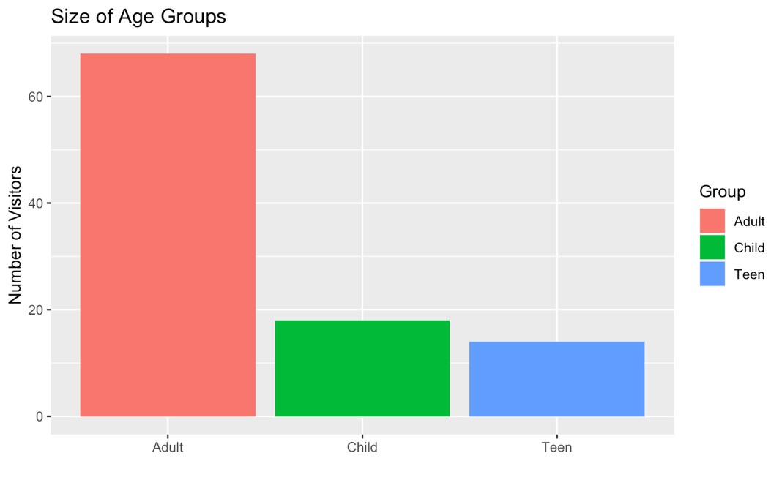
RESULTS
Of the 100 people surveyed, 68 were adults, 18 were children, and 14 were teenagers, approximately aged 13 to 18 years old. (Figure 6a). For time spent at the exhibit, each of the three groups had their highest percentage spend one minute or more at the exhibit. Adults spent the most time viewing the exhibit, followed by teenagers and children. For the visitor interaction, adults tended to look at the poster and video (Figure 6b). Children and teenagers interacted the most with the wheels, followed by the poster and video.
Figure 6a: The sample sizes within the different visitor age groups.
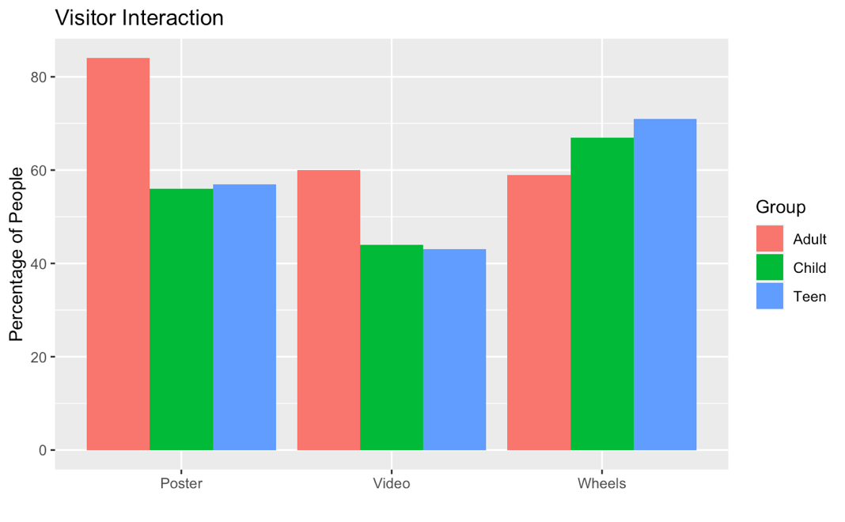
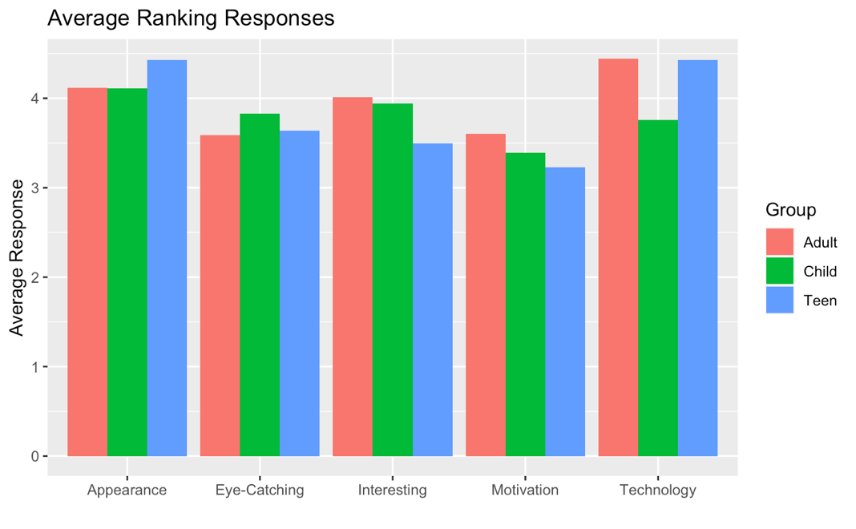
For the quantitative questions, responses among the age groups were similar (Figure 6c). The average response for the appearance of the exhibit was above 4 for each group with teenagers having the highest average. Children found the exhibit the most eye-catching with a ranking above 3.75. Adults were the most motivated to learn about plankton as well as found the material the most interesting. Teenagers and adults both found the material easy to understand with responses near 4.5. Children found the material more difficult to understand with an average around 3.75.
Figure 6b: Percentage of age groups that interacted with the poster, video, and wheels.
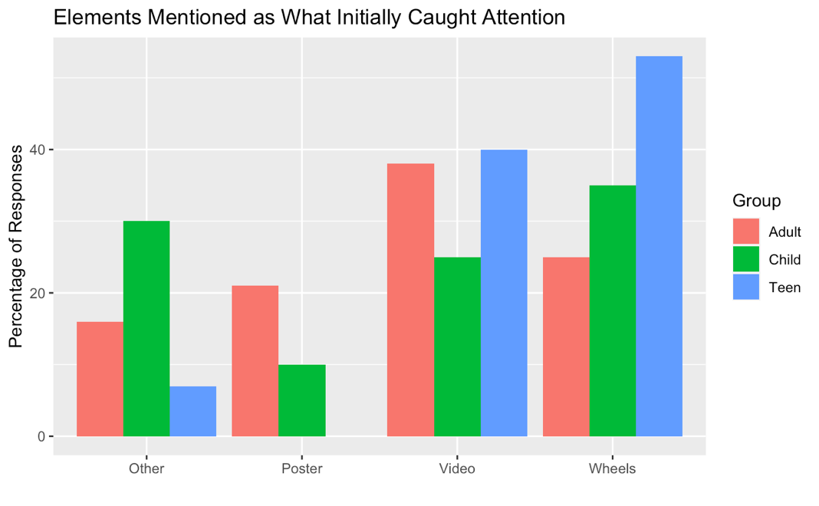
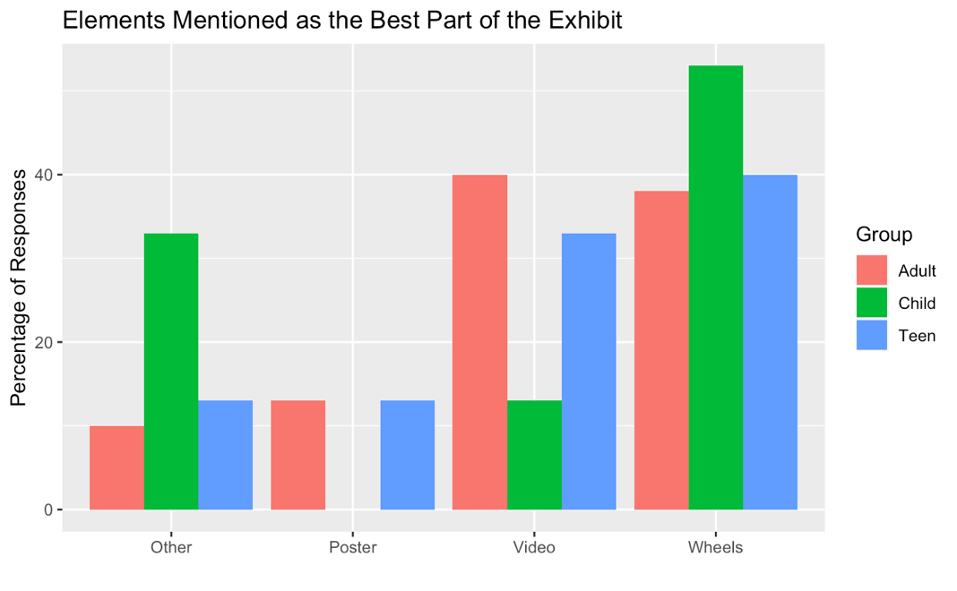
When asked what initially caught their attention, process elements were listed more than product for each group. The process responses included, “Compelling colors,” and “The blue against the green.” A few of the product responses were, “The microscopic pictures of plankton,” and “How to catch images of plankton.” When looking at what elements caught their attention, regardless or process or product, it was found that the wheels were the main element that caught the teenagers’ attention (Figure 6d). The children also referenced the wheels and other elements in their responses. Some examples of responses that fell into “other” included “grouper” and “fish.” Within the adult group, the video had the highest percentage of responses.
Figure 6d: Percentage of responses among age groups that mentioned poster, video, wheels, or other as what initially caught attention.
Figure 6c: Average responses for the quantitative ranking questions among age groups.
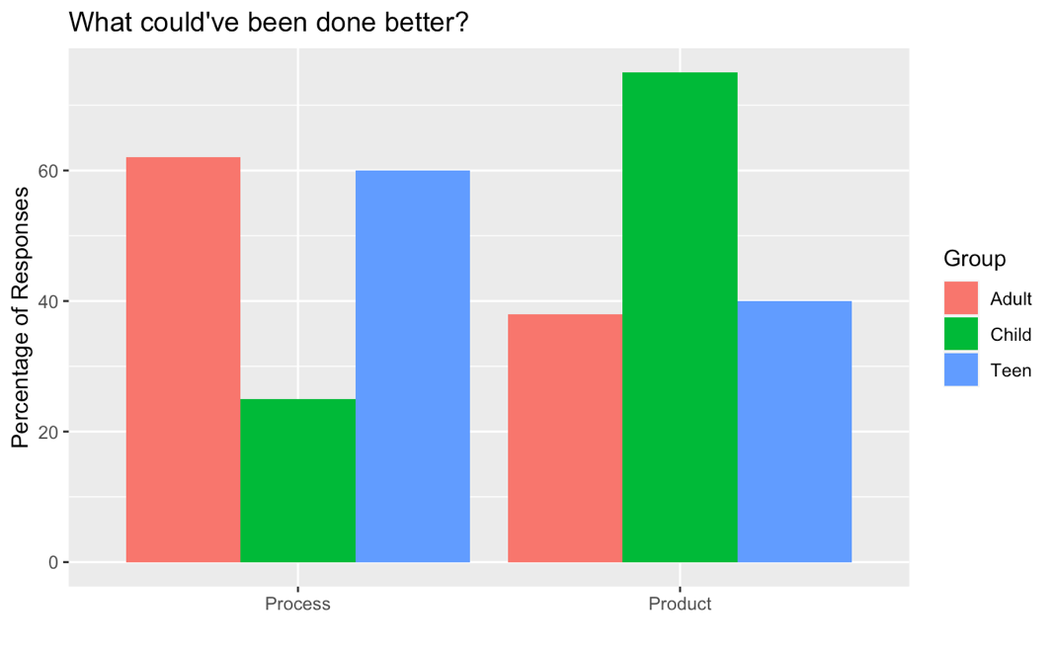
When asked “what was the best part of the exhibit?” all groups referenced process components over product. Some of the process answers included, “The interactive aspect” and “The video,” whereas the product responses included, “The plankton” and “The video showing the actual process.” When looking at their response regardless of process or product, the children had the highest percentage of responses for wheels, followed by “other” and the video (Figure 6e). None of the children listed the poster as the best part of the exhibit. The adults listed the video as the best part with wheels closely behind. The teenagers also enjoyed the wheels and video. The responses that fell into “other” for these responses include “crabs” and “the fish.”
Figure 6e: Percentage of responses among age groups that mentioned poster, video, wheels, or other as the best part of the exhibit.
When asked what could’ve been done better, children listed the most product elements, whereas teenagers and adults asked for more process components (Figure 6f). Children asked for “more life cycle examples” and “different species,” whereas adults and teenagers listed “lighting,” “location,” and “brighter colors.” Representatives from all groups mentioned adding a live example to the exhibit or expanding on the information, but there was also a call for more interactive parts, sound on the video, etc.
Figure 6f: Percentage of responses among age groups that answered changes or increases in process or product.

Discussion and Conclusions
I expected that the different age groups would rank the quantitative questions similarly, and their responses did show many commonalties. However, there were some differences. When asked how well they understood the technology, children ranked the lowest, but the children thought the exhibit was the most eye-catching of the three groups. We expected there to be some confusion with the technology with younger age groups, which is one reason we chose to include the spinning wheels. Adults were more intrigued by the content of the exhibit. They found the material the most interesting as well as were the most motivated to learn more about plankton and ocean life cycles. Teenagers fell in between the two groups, tending to rank lower than the other two groups in how interesting the material is and the motivation to learn more. However, they gave the highest ranking of the three groups for the exhibit’s appearance.
Adults and children view aspects of educational exhibits differently (Tunnicliffe, 1996). A balance between product and product elements is required for the exhibit to be effective and successful in learning. The children were expected to be attracted and interested in the interactive aspects of the exhibit while the adults were expected to engage with the visual components. The results did show differences in interaction between age groups. Adults tended to engage more with the visual components like the poster and video. Most adults listed the video as what initially caught their attention as well as the best part of the exhibit. In contrast, the children enjoyed engaging with the spinning wheels, with the majority listing the wheels as what initially caught their attention as well as the best part of the exhibit. Teenagers tended to fall in between the two groups. They interacted with mostly the wheels and poster but listed the wheels and video as the best parts of the exhibit. The qualitative portion of the exhibit also revealed that process caught visitors’ attention and maintained it during the duration of their viewing. Furthermore, visitors asked more changes/increases in process components of the exhibit. Children were the anomaly, wanting to learn more about the content of the exhibit.
For future studies, it would be helpful to further distinguish between process and product to get a better understanding of the visitors’ engagement. For this project, general terms such as “video,” “wheel,” and “poster,” were placed into “process.” More descriptive terms such as “plankton,” “life cycle,” and “technology,” were placed in “product.” A lot of visitors mentioned these general terms, so it would have been helpful to somehow get further clarification on whether which category best fit their response. One way to get more personalized responses would be to increase the qualitative portion of the survey. More one-on-one interviews would help clarify responses and get more reflection on the exhibit. Also, a larger sample size, with more equal representation among age groups, would have given a better representation of the visitors’ engagement. There were much fewer children and teenagers within the sample than adults.
The results of this survey revealed several aspects to consider in future exhibit designs. There were some process components that were out of our control, such as the existing lighting within the aquarium and the available wall space. However, there were several aspects that would be beneficial to include and consider. All age groups, especially children, enjoyed the spinning wheels. Adding more interactive elements in future exhibits would help increase engagement through encouraging hands-on activities. Many people also requested a “live example” of the plankton. Since plankton can be small, this could be difficult and would require creative thinking. Perhaps there could be a way to incorporate a live stream or viewing of the plankton. Maybe a microscope with samples could be set up next to the exhibit. Being able to incorporate more hands on and visual elements would be very beneficial in the design of such an element. It would also make the exhibit more eye-catching for visitors, which was also mentioned in the responses.
The results from this project have broad applications for all types of science communication. Findings from this study can be incorporated into coastal community events and other marine science outreach. However, the themes and results from this study can be applied to many other scientific disciplines. Process and product features are prevalent in any type of exhibit, and the results from this study show differences in engagement among age groups. Knowing your audience and learning goals are helpful in understanding where the emphasis needs to be placed during exhibit development. For this study, adults preferred more visual components, whereas children preferred interactive features. The aesthetic and layout of the exhibit proved to be the main force that drew in the public. Then the content was able to inform and educate visitors. Learning what sparks engagement allows exhibit designers to plan accordingly in their future designs, no matter the scientific emphasis or type of institution.
This project showed how shadowgraph images can be used in educational exhibits and how certain exhibit elements can increase engagement among aquarium visitors. Images from towed camera systems can be used to create dynamic exhibits that can appeal to a variety of age groups. Having different components in an exhibit aid in initiating and increasing engagement in a variety of age groups. Through the creation of this exhibit and the survey that evaluated its effectiveness, we see that shadowgraph images can be used within educational exhibits and the ways in which we present the technology can increase engagement among certain age groups.
Through participating in the development, design, and delivery of a marine science exhibit, I have gained a unique perspective into the different facets of marine science communication. The development of this exhibit has allowed me to become a better science communicator through challenging me to understand, interpret, and then impart marine science topics to diverse and broad audiences. Learning how to promote engagement on a topic that is less understood by the public, such as plankton, has challenged me to critically think about how to utilize multiple forms of media to spark interest in the subject. As our technology and research advance, knowing how to communicate science into a language that promotes understanding and enthusiasm among the public is necessary to advocate for change in society.

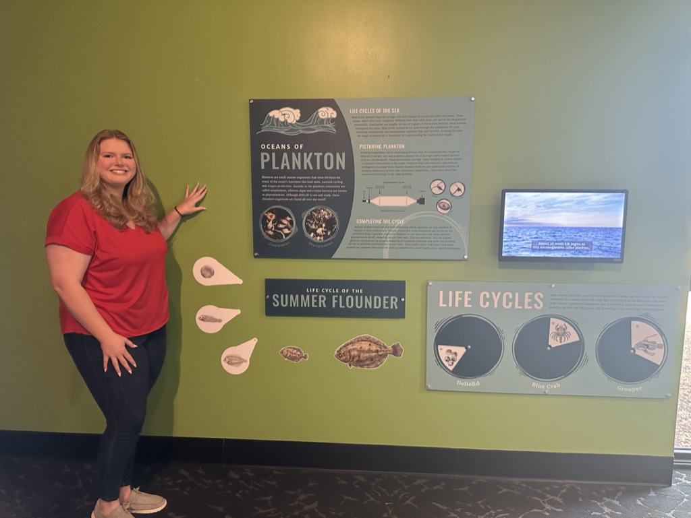

Figure 7: Standing next to the completed exhibit at the UGA MAREX Aquarium.

REFERENCES
Achiam, M. F. (2013). A content-oriented model for Science Exhibit Engineering. International Journal of Science Education, Part B, 3(3), 214–232. https://doi.org/10.1080/21548455.2012.698445
Afonso, A. S., & Gilbert, J. K. (2007). Educational value of different types of exhibits in an interactive science and technology center. Science Education, 91(6), 967–987. https://doi.org/10.1002/sce.20220
Allen, S. (2004). Designs for learning: Studying science museum exhibits that do more than entertain. Science Education, 88(S1). https://doi.org/10.1002/sce.20016
Benfield, M., Grosjean, P., Culverhouse, P., Irigolen, X., Sieracki, M., Lopez-Urrutia, A., Dam, H., Hu, Q., Davis, C., Hanson, A., Pilskaln, C., Riseman, E., Schulz, H., Utgoff, P., & Gorsky, G. (2007). Rapid: Research on automated plankton identification. Oceanography, 20(2), 172–187. https://doi.org/10.5670/oceanog.2007.63
Bowen, R. S. (2017). Understanding by Design. Vanderbilt University Center for Teaching. Retrieved [April 4, 2023] from https://cft.vanderbilt.edu/understanding-by-design/.
Greer, A., Walles, T., Duffy, P., Cousin, C., Treible, L., Aaron, K., Nejstgaard, J. (submitted). Modular shadowgraph imaging to resolve zooplankton distributions in diverse field and mesocosm settings. Limnology and Oceanography: Methods.
Greer, A.T., Schmid, M.S., Duffy, P.I., Robinson, K.L., Genung, M.A., Luo, J.Y., Panaïotis, T., Briseño-Avena, C., Frischer, M.E., Sponaugle, S. and Cowen, R.K. (2023). In situ imaging across ecosystems to resolve the fine-scale oceanographic drivers of a globally significant planktonic grazer. Limnology and Oceanography. 68: 192-207. https://doi.org/10.1002/lno.12259
Haywood, N., & Cairns, P. (2006). Engagement with an interactive museum exhibit. People and Computers XIX — The Bigger Picture, 113–129. https://doi.org/10.1007/1-84628-249-7_8
Kohen, Z., & Dori, Y. J. (2018). Toward narrowing the gap between science communication and Science Education Disciplines. Review of Education, 7(3), 525–566. https://doi.org/10.1002/rev3.3136
Literacy Statistics. ThinkImpact.com. (2022, October 15). Retrieved May 1, 2023, from https://www.thinkimpact.com/literacy-statistics/.
Lombard, F., Boss, E., Waite, A. M., Vogt, M., Uitz, J., Stemmann, L., Sosik, H. M., Schulz, J., Romagnan, J.-B., Picheral, M., Pearlman, J., Ohman, M. D., Niehoff, B., Möller, K. O., Miloslavich, P., Lara-Lpez, A., Kudela, R., Lopes, R. M., Kiko, R., … Appeltans, W. (2019). Globally consistent quantitative observations of planktonic ecosystems. Frontiers in Marine Science, 6. https://doi.org/10.3389/fmars.2019.00196
Marcy, K. (2021, May 26). Interesting Zoo and Aquarium Statistics. Association of Zoos & Aquariums. Retrieved May 1, 2023, from https://www.aza.org/connect-stories/stories/interesting-zoo-aquarium-statistics?locale=en.
Moss, A. G., & Pavitt, B. (2019). Assessing the effect of zoo exhibit design on visitor engagement and attitudes towards conservation. Journal of Zoo and Aquarium Research, 7(4), 186–194. https://doi.org/10.19227/jzar.v7i4.422
Nick. (2021, September 16). What is Sci-Comm. Scientia Global. Retrieved May 1, 2023, from https://www.scientia.global/what-is-sci-comm/.
NOAA. (2020, March 27). What are Plankton? National Ocean Service. Retrieved May 1, 2023, from https://oceanservice.noaa.gov/facts/plankton.html.
NOAA. (2022, December 23). Summer flounder. National Ocean Service. Retrieved May 1, 2023, from https://www.fisheries.noaa.gov/species/summer-flounder.
Panagiotis Zaharias, Despina Michael, & Yiorgos Chrysanthou. (2013). Learning through Multi-touch Interfaces in Museum Exhibits: An Empirical Investigation. Journal of Educational Technology & Society, 16(3), 374–384. http://www.jstor.org/stable/jeductechsoci.16.3.374
Positive Travel. (2020, January 7). The Top 10 Most Instagrammed Marine Animals. Retrieved May 1, 2023, from https://positive.travel/articles/awareness/the-10-most-instagrammed-marine-animals/.
Ross, S. R., & Gillespie, K. L. (2009). Influences on visitor behavior at a modern immersive zoo exhibit. Zoo Biology, 28(5), 462–472. https://doi.org/10.1002/zoo.20220
Stufflebeam, D. L. (2000). The CIPP Model for Evaluation. Evaluation Models: Evaluation in Education and Human Services, 279–317. https://doi.org/10.1007/0-306-47559-6_16
Tunnicliffe, S.D (1996). The relationship between pupils' age and the content of conversations generated at three types of animal exhibits. Research in Science Education 26, 461–480. https://doi.org/10.1007/BF02357455
Visitor Demographics. Association of Zoos and Aquariums. (n.d.). Retrieved May 1, 2023, from https://www.aza.org/partnerships-visitor-demographics?locale=en.
Wickham, H (2016). ggplot2: Elegant Graphics for Data Analysis. Springer-Verlag New York.

SUPPLEMENTARY MATERIAL
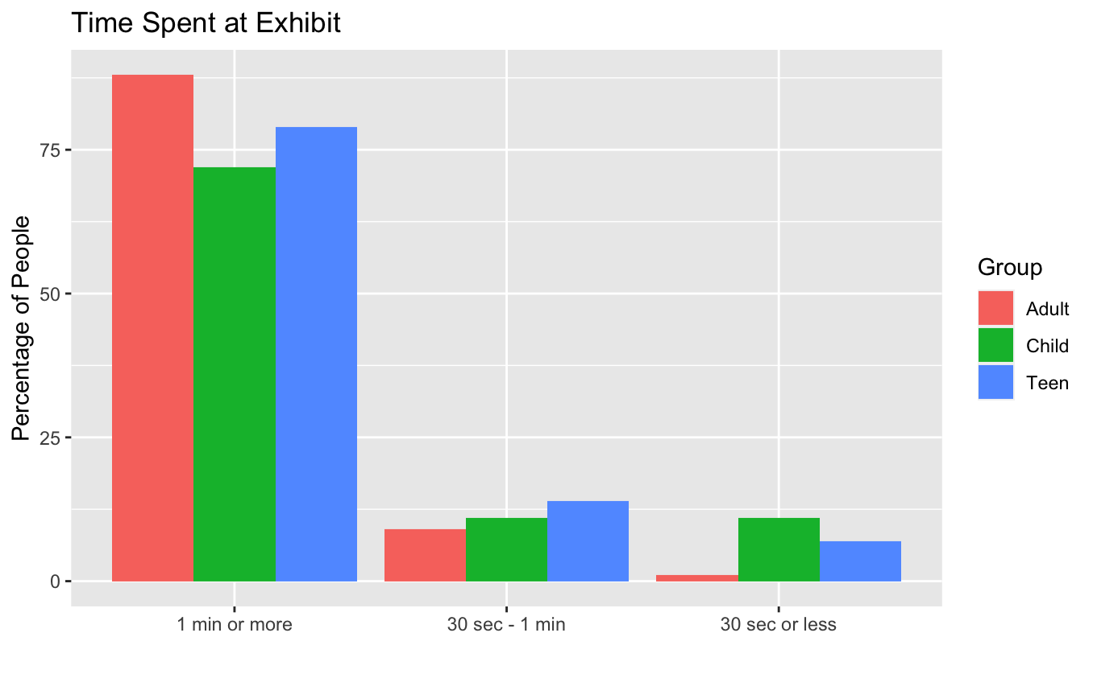
Figure 2: Approximate amount of time spent at the exhibit.

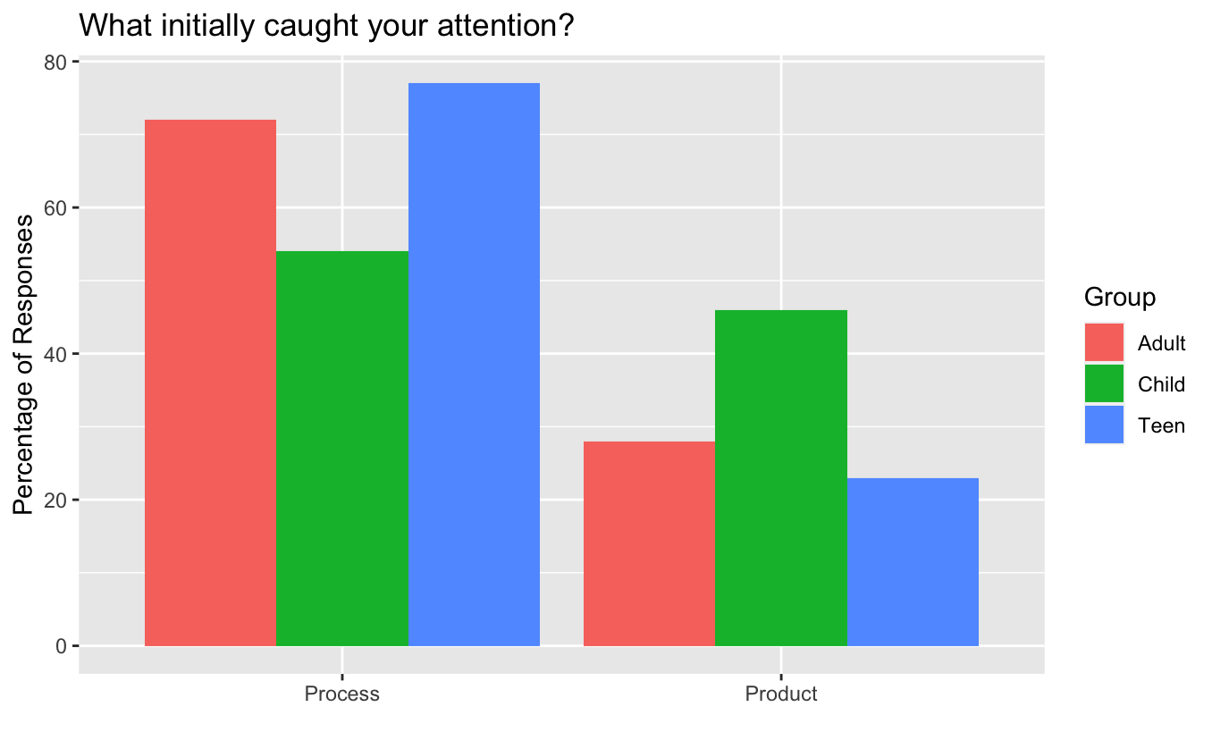
Figure 3: Responses that fit process or product for what initially caught attention at the exhibit.
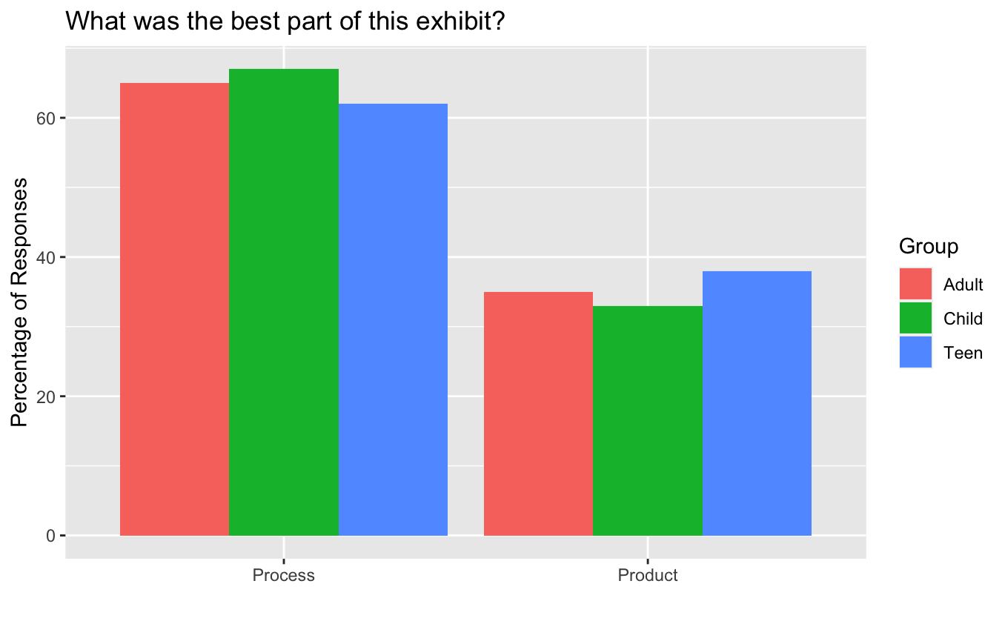
Figure 4: Responses that fit process or. product for the best part of the exhibit.

